4.7.1 | Adaptations, interdependence and competition
4.7.1.1 Communities  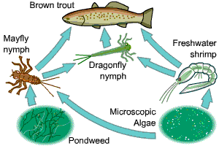 | An ecosystem is the interaction of a community of living organisms (biotic) with the non-living (abiotic) parts of their environment.  To survive and reproduce in a community, plants compete with each other for light and space, and water and mineral ions from the soil. Animals compete with each other for food, mates and territory.  Each species in a community depends on other species for food, shelter, pollination and seed dispersal, etc. If one species is removed it can affect the whole community. This is called interdependence. A stable community is where all the species and environmental factors are in balance for a constant population sizes.
4.7.1.2 Abiotic factors | A change in an abiotic (non-living) factor would affect a given community. This includes light intensity, temperature, moisture levels, soil pH and mineral content, wind intensity and direction, carbon dioxide levels for plants, oxygen levels for aquatic animals.
4.7.1.3 Biotic factors | Biotic (living) factors which can affect a community are:  availability of food, new predators arriving, new pathogens or one species outcompeting another.
4.7.1.4 Adaptations  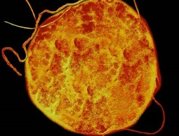 | Organisms have features (adaptations) that enable them to survive in conditions in which they normally live. These adaptations may be structural, behavioural or functional. Organisms called extremophiles live in environments that are very extreme, such as at high temperature, pressure, or salt concentration. Bacteria living in deep sea vents are extremophiles.

4.7.2 | Organisation of an ecosystem
4.7.2.1 Levels of organisation  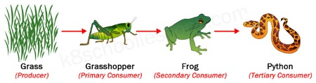 | Feeding relationships in a community is represented by food chains. It begins with a producer (green plant or alga) which synthesises molecules such as glucose for photosynthesis. Producers are eaten by primary consumers, which may be eaten by secondary consumers and then tertiary consumers. Consumers that kill and eat other animals are predators, and those eaten are prey. In a stable community the numbers of predators and prey rise and fall in cycles.  Methods such as transects and quadrats are used by ecologists to determine the distribution and abundance of species in an ecosystem.
4.7.2.2 How materials are cycled  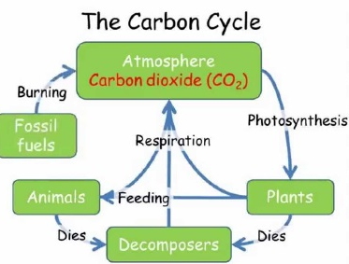 | All materials in the living world are recycled to provide the building blocks for future organisms.  CARBON CYCLE returns carbon from organisms to the atmosphere in the form of carbon dioxide. It involves four main processes:  - Photosynthesis:  removes carbon (dioxide) from the air, by green plants, used to make carbohydrates, fats and proteins.  - Respiration:  chemical reaction in all living cells, which releases carbon dioxide back into the air.  - Decay (or decomposition):  Dead organic material is broken down (digested) by microorganisms. This releases nutrients back into the soil needed for plants to grow.  - Combustion  burning or (fossil) fuels, which is releases more carbon  dioxide into the atmosphere  - WATER CYCLE provides fresh water for plants and animals on land before draining into the seas. Water is continuously evaporated and precipitated.
4.7.2.3 Decomposition (BIOLOGY only) | Gardeners and farmers try to provide optimum (best) conditions for rapid decay of waste biological material (compost). The rate of decay can be affected by temperature, water and the availability of oxygen.  The compost produced is used as a natural fertiliser for growing garden plants or crops. Anaerobic (no oxygen) decay produces methane gas. Biogas generators can be used to produce methane gas as a fuel.
4.7.2.4 Impact of environmental change (biology only) (HT only) | The distribution of species in an ecosystem can be affected by environmental changes (temperature, availability of water and composition of atmospheric gases. The changes may be seasonal, geographic or caused by human interaction.

4.7.3 | Biodiversity and the effect of human interaction on ecosystems
4.7.3.1 Biodiversity  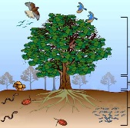 | Biodiversity is the variety of all the different species of organisms on earth, or within an ecosystem. Greater biodiversity ensures the stability of ecosystems by reducing the dependence of one species on another.
4.7.3.2 Waste management  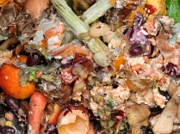 | Rapid growth in the human population and an increase in the standard of living means more resources are used and more waste is produced. Waste and chemical materials need to be properly handled to reduce pollution. Pollution can occur in water (from sewage, fertilisers or toxic chemicals), in air (from smoke and acidic gases), on land (from landfill and chemicals) and can kill plants and animals.
4.7.3.3 Land use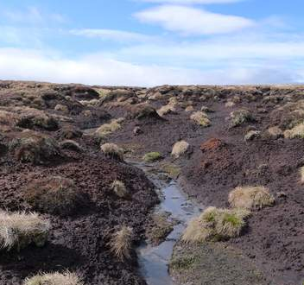 | Humans reduce the amount of land available for other animals and plants by building, quarrying, farming and dumping waste.  Peat bogs, formed in waterlogged bogs over thousands of years by the growth of mosses and other plants, absorb and ‘lock away’ carbon. They are being destroyed to produce garden compost, reducing the area of this habitat and the variety of different plant, animal and microorganism species that live there. The decay or burning of the peat releases carbon dioxide into the atmosphere.
4.7.3.4 Deforestation | Large-scale deforestation in tropical areas has occurred to provide land for cattle and rice fields and grow crops for biofuels.
4.7.3.5 Global warming  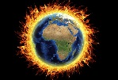 | Carbon dioxide and methane levels in the atmosphere are increasing, and contribute to ‘global warming’.
4.7.3.6 Maintaining biodiversity | Scientists and citizens have recommended programmes to maintain biodiversity. These include breeding programmes for endangered species, protect and regenerate rare habitats, reintroduce field margins and hedgerows in agricultural areas where farmers grow only one type of crop, reduce deforestation and carbon dioxide emissions, recycle rather than dump in landfills.

4.7.4 | 4.7.4 Trophic levels in an ecosystem (biology only)
4.7.4.1 Trophic levels  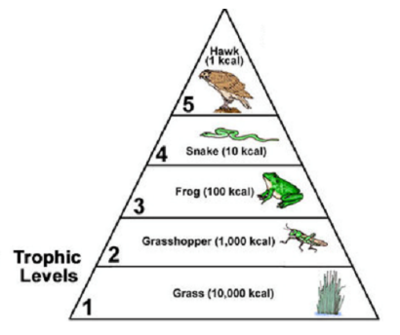 | Trophic levels can be represented by numbers, starting at level 1 with plants and algae. Further trophic levels are numbered subsequently according to how far the organism is along the food chain.  Level 1: Plants and algae make their own food and are called producers. Level 2: Herbivores eat plants/algae and are called primary consumers. Level 3: Carnivores that eat herbivores are called secondary consumers. Level 4: Carnivores that eat other carnivores are called tertiary consumers. Apex predators are carnivores with no predators.  Decomposers break down dead plant and animal matter by secreting enzymes into the environment. Small soluble food molecules then diffuse into the microorganism.
4.7.4.2 Pyramids of biomass | Pyramids of biomass can be constructed to represent the amount of biomass in each level of a food chain. Trophic level 1 is at the bottom of. 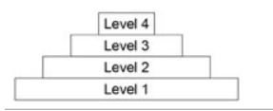
4.7.4.3 Transfer of biomass | Producers (plants and algae) transfer about 1% of the incident energy from light for photosynthesis. Only around 10% of the biomass from each trophic level is transferred to the level above it.  Loss of biomass is because: not all the ingested material is absorbed, only some is egested as faeces, some lost as waste (such as carbon dioxide and water in respiration and water and urea in urine). Large amounts of glucose are used in respiration.  Equation: The percentage efficiency of energy transfer between trophic levels = energy transferred to next level ÷ total energy in × 100

4.7.5 | 4.7.5 Food production (biology only)
4.7.5.1 Factors affecting food security  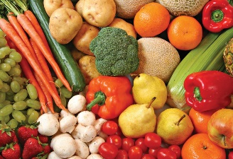 | Food security is having enough food to feed a population.  Biological factors threatening food security include: • increasing birth rate, changing diets in developed countries means scarce food resources are transported around the world, new pests and pathogens that affect farming, environmental changes (widespread famine in countries if rains fail), the cost of agricultural inputs, conflicts in some parts of the world.
4.7.5.2 Farming techniques  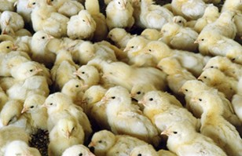 | Food production can be improved by limiting energy transfer from food to animals to the environment. Examples include, restricting animal movement and keeping them close together (so less energy is wasted), controlling the temperature of their surroundings or high protein diets to increase growth.
4.7.5.3 Sustainable fisheries | Fish stocks in the oceans are declining (going down). Certain species of fish may disappear if fish stocks levels are not maintained. Control of net size and the introduction of fishing quotas can help in conserving fish stocks at a sustainable level.
4.7.5.4 Role of biotechnology  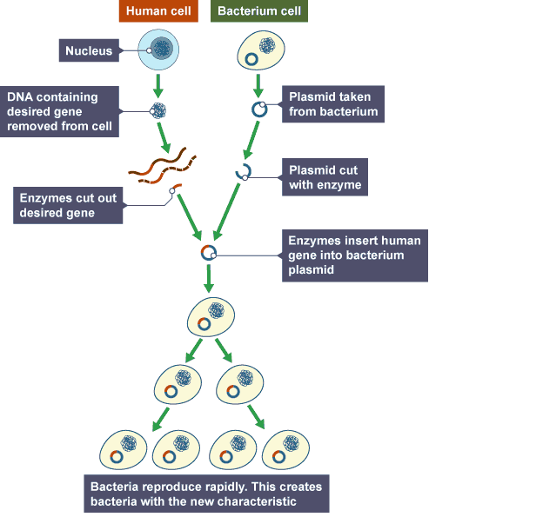 | Modern biotechnology techniques enable large quantities of microorganisms to be cultured for food. The fungus Fusarium, for example, is useful for producing mycoprotein, a protein-rich food suitable for vegetarians. The fungus is grown on glucose syrup in aerobic (oxygen) conditions and the biomass is harvested and purified.  Genetic engineering: Genes from the chromosomes of humans and other organisms can be ‘cut out’ using enzymes and transferred to cells of other organisms.  - GM crops that have been given beneficial traits (eg. resistant to insect attack or to herbicides or improved nutritional value such as golden rice)  - Bacteria that are genetically modified to produce human insulin (for diabetics)  (HT): Steps involved in genetic engineering  Enzymes are used to isolate and cut out the desired gene; this gene is inserted into a vector, usually a bacterial plasmid or a virus. The plasmid or vector reproduces quickly with the desired characteristics.

