Anaemia
Iron deficiency anaemia is a condition where a lack of iron in the body leads to a reduction in the number of red blood cells.
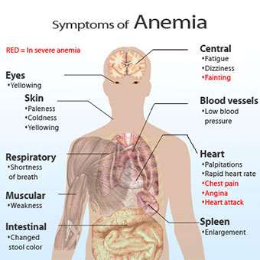
Iron
Iron is used to produce red blood cells, which help store and carry oxygen in the blood. If you have fewer red blood cells than is normal, your organs and tissues won't get as much oxygen as they usually would.
Anaemia can be caused by a lack of vitamin B12 or folate in the body – read more about vitamin B12 and folate deficiency anaemia.

Causes
There are many things that can lead to a lack of iron in the body. In men and post-menopausal women, the most common cause is bleeding in the stomach and intestines.
In women of reproductive age, heavy periods and pregnancy are the most common causes of iron deficiency anaemia as your body needs extra iron for your baby during pregnancy.
Unless you're pregnant, it's rare for iron deficiency anaemia to be caused just by a lack of iron in your diet.

Good sources of iron
- dark-green leafy vegetables, such as watercress and curly kale
- iron-fortified cereals or bread
- brown rice
- pulses and beans
- nuts and seeds
- meat, fish and tofu
- eggs
- dried fruit, such as dried apricots, prunes and raisins

