4.1 Cell biology
4.1.1 | Cell structure
4.1.1.1 Eukaryotes and prokaryotes  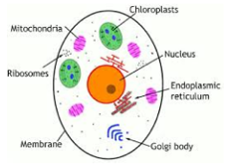  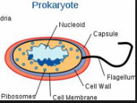 | Plant and animal cells (eukaryotic cells) have a cell membrane, cytoplasm and genetic material enclosed in a nucleus.  Bacterial cells (prokaryotic cells) are much smaller in comparison. They have cytoplasm and a cell membrane surrounded by a cell wall. The genetic material is not enclosed in a nucleus. It is a single DNA loop and there may be one or more small rings of DNA called plasmids.  Use prefixes centi 1/100, milli 1/1000, micro1/10⁶ and nano 1/10^{9.}
4.1.1.2 animal and plant cells | Most animal cells have the following parts: a nucleus for control, cytoplasm – chemical reactions take place, a cell membrane – controls what enters and leaves, mitochondria – release energy by respiration, ribosomes – protein synthesis.  In addition to the parts found in animal cells, plant cells often have: chloroplasts, a permanent vacuole filled with cell sap.  Plant and algal cells also have a cell wall made of cellulose, which strengthens the cell.
4.1.1.3 cell specialisation | Cells may be specialised to carry out a particular function:  • sperm cells, nerve cells and muscle cells in animals  • root hair cells, xylem (water transport) and phloem cells (sugar transport) in plants.
4.1.1.4 cell differentiation | As an organism develops, cells differentiate to form different types of cells.  • Most types of animal cell differentiate at an early stage.  • Many types of plant cells retain the ability to differentiate throughout life.  In mature animals, cell division is mainly restricted to repair and replacement. As a cell differentiates it acquires different sub-cellular structures to enable it to carry out a certain function. It has become a specialised cell.
4.1.1.5 microscopy | Electron microscopy has increased understanding of sub-cellular structures.  An electron microscope has much higher magnification and resolving power than a light microscope. This means that it can be used to study cells in much finer detail.  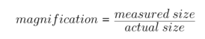
4.1.1.6  culturing microorgansisms (biology only)  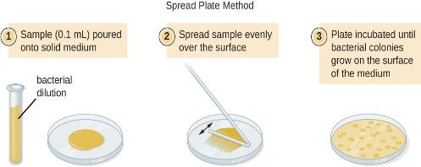 | Bacteria multiply by simple cell division (binary fission) as often as once every 20 minutes if they have enough nutrients and a suitable temperature.  Bacteria can be grown in a nutrient broth solution or as colonies on an agar gel plate. Uncontaminated cultures of microorganisms are required for investigating the action of disinfectants and antibiotics.  Prepare an uncontaminated culture using aseptic technique by.  • Petri dishes and culture media must be sterilised before use so only the desired microorganism is grown  •inoculating loops used to transfer microorganisms to the media must be sterilised by passing them through a flame  • the lid of the Petri dish should be secured with adhesive tape and  stored upside down to stop any microorganisms entering or leaving  • in school laboratories, cultures should generally be incubated at 25°C. to stop growth being too rapid
4.1.2 | Cell division
4.1.2.1 chromosomes | The nucleus of a cell contains chromosomes made of DNA molecules.  Each chromosome carries a large number of genes.  In body cells the chromosomes are normally found in pairs.
4.1.2.2 mitosis and the cell cycle  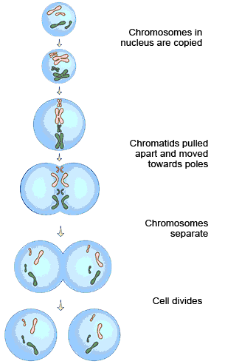 | Cells divide in a series of stages called the cell cycle.  During the cell cycle the genetic material is doubled and then divided  into two identical cells.  Before a cell can divide it needs to grow and increase the number of  sub-cellular structures such as ribosomes and mitochondria. The DNA replicates (copies itself) to form two copies of each chromosome.  In mitosis one set of chromosomes is pulled to each end of the cell and the nucleus divides.  Finally the cytoplasm and cell membranes divide to form two identical  cells. Cell division by mitosis is important in the growth and development of multicellular organisms.
4.1.2.3 stem cells  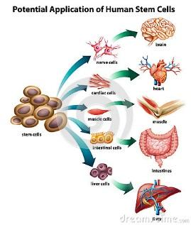 | A stem cell is an undifferentiated cell of an organism which is capable of giving rise to many more cells of the same type, and from which certain other cells can arise from differentiation.  Stem cells from human embryos can be cloned and made to  differentiate into most different types of human cells. Stem cells from adult bone marrow can form many types of cells including blood cells.  Meristem tissue in plants can differentiate into any type of plant cell, throughout the life of the plant.  Treatment with stem cells may be able to help conditions such as  diabetes and paralysis.  In therapeutic cloning an embryo is produced with the same genes as the patient. Stem cells from the embryo are not rejected by the patient’s body so they may be used for medical treatment.  The use of stem cells has potential risks such as transfer of viral  infection, and some people have ethical or religious objections.  Stem cells from meristems in plants can be used to produce clones of  plants quickly and economically.  • Rare species can be cloned to protect from extinction.  • Crop plants with special features such as disease resistance can be  cloned to produce large numbers of identical plants for farmers.
4.1.3 | Transport in cells
4.1.3.1 diffusion  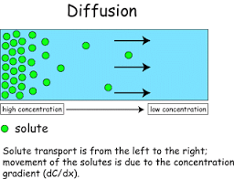 | Substances may move into and out of cells across the cell membranes via diffusion. Diffusion is the spreading out of the particles of any substance in solution, or particles of a gas, resulting in a net movement from an area of higher concentration to an area of lower concentration.  Some of the substances transported in and out of cells by diffusion are oxygen and carbon dioxide in gas exchange, and of the waste product urea from cells into the blood plasma for excretion in the kidney.  Factors which affect the rate of diffusion are:  •• the difference in concentrations (concentration gradient)  •• the temperature  •• the surface area of the membrane.  A single-celled organism has a relatively large surface area to volume  ratio. This allows sufficient transport of molecules into and out of the cell to meet the needs of the organism.  In multicellular organisms, surfaces and organ systems are specialised for exchanging materials. This is to allow sufficient molecules to be transported into and out of cells for the organism’s needs. The effectiveness of an exchange surface is increased by:  • having a large surface area (e.g. gills in fish, alveoli in lungs)  • a membrane that is thin, to provide a short diffusion path  • (in animals) having an efficient blood supply  • (in animals, for gaseous exchange) being ventilated.

4.1.3.2  osmosis | Water may move across cell membranes via osmosis. Osmosis is the diffusion of water from a dilute solution to a concentrated solution through a partially permeable membrane.  (Or you can phrase it as: Osmosis is the diffusion of water from a high water concentration to a low water concentration through a partially permeable membrane.)
4.1.3.3 active transport | Active transport moves substances from a more dilute solution to a more concentrated solution (against a concentration gradient). This requires energy from respiration.  Active transport allows mineral ions to be absorbed into plant root hairs from very dilute solutions in the soil. Plants require ions for healthy growth.  It also allows sugar molecules to be absorbed from lower concentrations in the gut into the blood which has a higher sugar concentration. Sugar molecules are used for cell respiration.

