4.2 Organisation – Knowledge organiser
Topic 1 – Principles of Organisation
1 | Cells | Cells are the basic building blocks of all living organisms.
2 | Tissues | A Tissue is a group of cells with a similar structure and function.
3 | Organs | Organs are made up of a number of tissues, which work together to perform a specific function. Example- the heart.
4 | Organ System | An organ system is a group of organs which work together to form organisms. Example- the digestive system.
5 | Organisation | 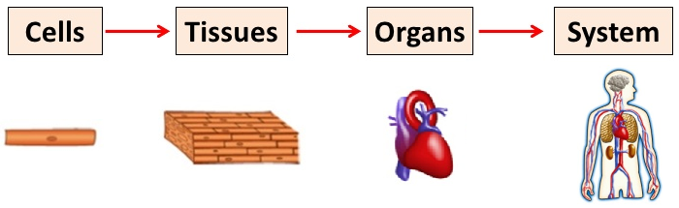
Topic 2 – Animal tissues, Organs and Organ Systems
1 | The Digestive system | Is an organ system in which several organs work together to digest and absorb food.  The digestive system is made up of the following parts:  - Glands- pancreas and salivary glands- produce digestive juices  - Stomach & small intestine- where digestion occurs  - Liver- produces bile  - Small Intestine- where digested food nutrients are absorbed  - Large Intestine- where water is absorbed from any undigested food, producing faeces.
 | Bile | Bile is made in the liver and stored in the gall bladder. It is alkaline to neutralise hydrochloric acid from the stomach. It also emulsifies fat to form small droplets which increases the surface area. The alkaline conditions and large surface area increase the rate of fat breakdown by lipase.
2 | Enzymes  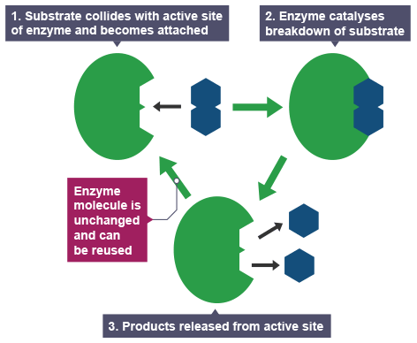 | Enzymes are biological catalysts (speed up chemical reactions in organisms).  Metabolism is the sum of all the chemical reactions in the body.  Lock and key model  Enzymes are folded into complex shapes that allow smaller molecules to fit into them. The place where these molecules fit is called the active site.  The shape of the active site matches the shape of its substrate molecules. This makes enzymes highly specific – each type of enzyme will only work with one type of reaction.  Enzymes are used in digestion to covert food into small soluble molecules which can be absorbed into the bloodstream.
 | Enzyme Activity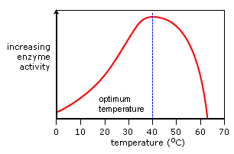 | Temperature  High temperatures change the shape of enzymes. If the temperature gets too high the enzyme will be denatured.  pH  Different enzymes work best at different pH values. This is called the optimum pH
3 | Carbohydrase  Amylase  Starch → sugars | Carbohydrase breaks down carbohydrates into simple sugars. Amylase is an example of a carbohydrase.  The enzyme amylase is produced in the salivary gland, pancreas and small intestine. It catalyses the breakdown of starch into sugars in the mouth and small intestine.
4 | Protease  Protein → amino acids | Protease enzymes are produced in the stomach, pancreas and small intestine.  It catalyses the breakdown of proteins into amino acids.
5 | Lipase  Lipids → Fatty acids + glycerol | Lipase enzymes are produced in the pancreas and small intestine.  It catalyses the breakdown of lipids (fats) into fatty acids and glycerol in the small intestine.
 | Products of digestion | The products of digestion are used to build new carbohydrates, lipids and proteins. Some glucose is used in respiration.
 | Food tests | Benedict’s Solution  Tests for sugars (glucose)  Positive result green, orange, red | Iodine Solution  Tests for starch  Positive result blue/black colour | Biuret Solution  Tests for protein  Positive result violet

Topic 3 – The Heart & Blood Vessels
1 | Heart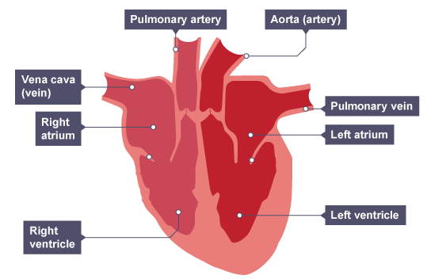 | The heart is an organ that pumps blood around the body in a double circulatory system.  -The right ventricle pumps blood to the lungs where gas exchange takes place.  -The left ventricle pumps blood around the whole body.
 | Heart Rate | The natural resting heart rate is controlled by a group of cells located in the right atrium that act as a pacemaker. Artificial pacemakers are electrical devices used to correct irregularities in the heart rate.
2 | Blood Vessels | Arteries:Carry blood away from the heart (except pulmonary artery), Have thick muscular walls, Contain blood under high pressure  Veins: Carry blood to the heart (except pulmonary vein), Have thin walls, Contain blood under low pressure, Have valves to prevent the blood flowing backwards  Capillaries:1 cell thick for effective diffusion, connect arteries to veins
3 | Lungs  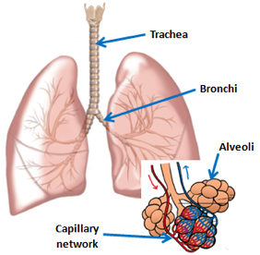 | Alveoli- have a large surface area and are one cell thick to allow fast gas exchange.  The alveoli are surrounded by a network of capillaries.
 | Blood | Blood is a tissue which is made up of plasma, red blood cells, white blood cells and platelets.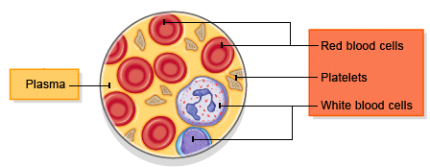  Red blood cells  - Flattened disc shape- large surface area for gas exchange.  - Contains haemoglobin- to absorb oxygen  - No nucleus- so the cell can hold more haemoglobin.  White blood cells Help to protect the body against infection  Platelets Help the blood to clot, forming a scab.  Plasma Contains dissolved substances and transports them around the body e.g. glucose and carbon dioxide.

Topic 4 – Health Issues
1 | Coronary Heart Disease | 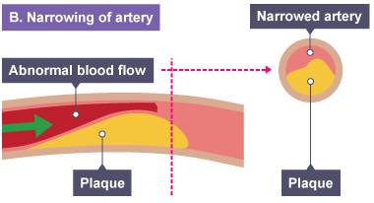 | The coronary arteries supply blood to the heart muscle.  Coronary heart disease- layers of fatty material build up inside the coronary arteries, narrowing them. This reduces the blood flow, reducing the amount of oxygen reaching the heart muscle.
2 | Treatments | Stents are used to keep the coronary arteries open. Statins are widely used to reduce blood cholesterol levels, which slows down the rate of fatty material deposit.
3 | Faulty Heart Valves | Faulty heart valves don’t open fully which can develop a leak. This can cause a backflow of blood which results in the heart having to work harder. Faulty valves can be replaced using biological valves (transplant) or mechanical valves.
4 | Heart Failure | Artificial hearts are occasionally used to keep patients alive whilst waiting for a heart transplant, or to allow the heart to rest as an aid to recovery.
5 | Health | Health is the state of physical and mental well-being.  Diseases are major causes of ill health. Other factors also have an impact on health such as stress, diet and life situations.
6 | Diseases | Communicable diseases- caused by pathogens, they can be transmitted.  Non-communicable diseases- not infectious diseases cannot be transmitted.  Non-communicable diseases are affected by lifestyle factors such as diet, exercise, alcohol and smoking.  Risk factors for some non-communicable diseases:  - Diet, smoking and exercise- cardiovascular disease  - Obesity – type 2 diabetes  - Smoking- lung disease and lung cancer  - Smoking and alcohol- development of unborn babies  - Carcinogens (e.g. ionising radiation)- cancer  Many diseases are caused by the interaction of a number of risk factors.

7 | Cancer | Cancer is uncontrolled cell division.  Benign tumour- growth of abnormal cells which are contained in one area. They do not invade other parts of the body.  Malignant tumour- cancer cells that invade neighbouring tissues. They spread to different parts of the body through the blood stream causing secondary tumours.  Cancers are caused by lifestyle risk factors and genetic risk factors.

Topic 5 – Plant Tissues, Organs and Systems
1 | Plant Organs & Tissues | Plant organs include the stem, roots and leaves.  Plant Tissues include:  - Epidermal tissue- which covers the plant  - Mesophyll- carries out photosynthesis  - Xylem- transports water & minerals up the stem from the roots to the leaves  - Phloem- transports glucose from the leaves up and down the stem to the rest of the plant  - Meristem- found at the growing tips of the shoots and roots (actively dividing cells)
2 | Structure of the leaf |  |  |  | 1. Wax cuticle: prevents water loss  2 & 6. Epidermis (upper & lower): top and bottom layers of cells  3. Palisade cells: packed with chloroplasts, where most photosynthesis happens (get most light as at the top of the leaf)  4. Spongy Mesophyll: contains air spaces between the cells to allow carbon dioxide to reach the palisade cells (large surface area)  5. Guard cells: open and close the stomata, which helps to prevent too much water loss  7. Stoma/stomata: holes on the underside of the leaf that allow carbon dioxide to diffuse into the leaf, and water and oxygen to diffuse out of the leaf.
3 | Transpiration |  | Transpiration is the movement of water in a plant (from the roots up to the leaves)  The rate of transpiration is affected by the temperature, humidity, air movement and light intensity.
 | Root hair cells  Plants absorb water from the soil by osmosis. Root hair cells are adapted for this by having a large surface area to speed up osmosis. Root hair cells use active transport to take minerals and ions from the soil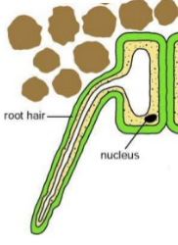 |  |  | Xylem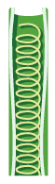  Xylem tissue transports water and mineral ions from the roots to the stems and leaves. It is composed of  hollow tubes strengthened by lignin adapted for the transport of water in the transpiration stream. |  | Phloem  Phloem tissue transports dissolved sugars from the leaves to the rest of the plant for immediate use or storage. The movement of food molecules through phloem tissue is called translocation. Phloem is composed of tubes of elongated cells. Cell sap can move from one phloem cell to the next through pores in the end walls.