B4.4 Bioenergetics – Knowledge organiser

Topic 1 – Photosynthetic reaction
1 | Photosynthesis  word equation | 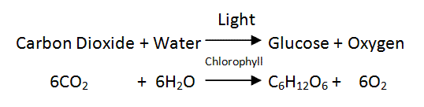
2 | Photosynthesis symbol equation | light  6CO₂ + 6H₂O C₆H₁₂O₆ + 6O₂  chlorophyll
3 | Photosynthesis | An ENDOTHERMIC reaction in which energy is transferred from the environment to the chloroplasts by light.

Topic 2 – Rate of photosynthesis
1 | Rate of photosynthesis | This is affected by temperature, light intensity, carbon dioxide concentration and the amount of chlorophyll.
2 | Limiting factors | Resources that limit the growth, abundance or distribution of an organism.
3 | Limiting factor graphs | Light  As the light intensity increases so does the rate of photosynthesis until the rate remains the same.  B  A: light intensity is the limiting factor  A  B: CO₂ concentration & temperature are the limiting factors | Carbon dioxide  As the carbon dioxide concentration increases, so does the rate of photosynthesis, until the rate remains the same.  B  A  A: CO₂ concentration is the limiting factor  B: light intensity & temperature are the limiting factors
 | A | Temperature  As the temperature increases, so does the rate of photosynthesis. It then reaches its optimum temperature, then the rate of photosynthesis decreases.  High temperatures change the shape of enzymes. If the temperature gets too high the enzyme will be denatured.  Temperature is the limiting factor.
4 | Inverse proportion  Economics | Light intensity obeys an inverse square law. This means that if you double the distance of the light source from the plant, you quarter the intensity.  Limiting factors are important in the economics of enhancing the conditions in greenhouses to gain the maximum rate of photosynthesis while still maintaining profit.

Topic 3 – Uses of glucose from photosynthesis
1 | Respiration | Plants use glucose for aerobic respiration.
2 | Converted to starch | Glucose gets converted to and stored as insoluble starch.
3 | Produce fats or oil | Glucose is used to produce fat or oil for storage.
4 | Produce cellulose | Glucose is used to produce cellulose, which strengthens the cell wall.
5 | Produce amino acids | Glucose is used to produce amino acids for protein synthesis. Plants also use nitrate ions that are absorbed from the soil.

Topic 4 – Aerobic & anaerobic respiration
1 | Respiration | Can take place in cells either AEROBICALLY (with oxygen) or ANAEROBICALLY (without oxygen), to transfer energy.
2 | Aerobic respiration | 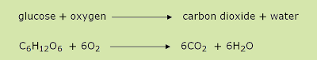
3 | Anaerobic respiration in muscles | 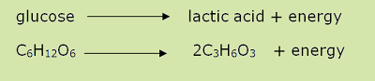  As the oxidation of glucose is incomplete, much less energy is transferred for use.
4 | Anaerobic respiration (plants & micro-organisms) | 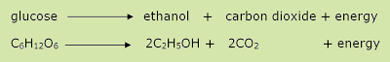  In yeast cells this is called fermentation and has economic importance in the manufacturing of bread and alcoholic drinks.

Topic 5 – Response to exercise
1 | Heart rate | This increases pumping MORE blood around the body.
2 | Breathing rate | This increases to take in MORE oxygen.
3 | Breath volume | This increase to take in MORE oxygen in each breath.
These increase to supply the muscles with MORE oxygenated blood for respiration.
4 | Oxygen debt | If insufficient oxygen is supplied to the muscles, anaerobic respiration takes place. The incomplete oxidation of glucose causes a build up of lactic acid and an oxygen debt. This is the amount of extra oxygen the body needs after exercise to react with the lactic acid and remove it from the cells.
5 | Lactic acid | Produced during long periods of vigorous activity. It causes muscles to become fatigued and stops them contracting efficiently.

Topic 6 – Metabolism
1 | Metabolism | The sum of all the reactions in a cell or the body.  The energy transferred by the respiration in cells is used for the continual enzyme controlled processes that synthesise new molecules.
2 | Metabolism includes: | Conversion of glucose to starch, glycogen and cellulose . The formation of lipid molecules from a molecule of glycerol and 3 molecules of fatty acids. The use of glucose and nitrate ions to form amino acids which in turn are used to synthesis proteins, Respiration, Breakdown of excess proteins to form urea for excretion.

