4.5.1 | Homeostasis
4.5.1  Homeostasis | Maintains optimal (best) conditions for enzyme action. Include control of blood glucose concentration; body temperature; water levels  Control systems include cells called receptors, which detect stimuli, coordination centres (brain, spinal cord, pancreas) which process information, effectors, muscles or glands which bring about responses.
4.5.2 | Human nervous system
4.5.2.1 Structure and function  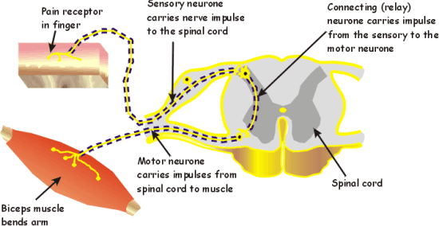 | Information from receptors passes along cells (neurones) as electrical  impulses to the central nervous system (CNS). The CNS is the brain and  spinal cord. The CNS coordinates the response of effectors which may  be muscles contracting or glands secreting hormones.  Stimulus receptor coordinator effector response  Synapses join different neurones. Chemicals are released and diffuse across the gap. This slows the impulse down  Reflexes are automatic and rapid. They do not involve the conscious part of the brain.  Remember the reaction time practical.
4.5.2.2 The brain (biology only)  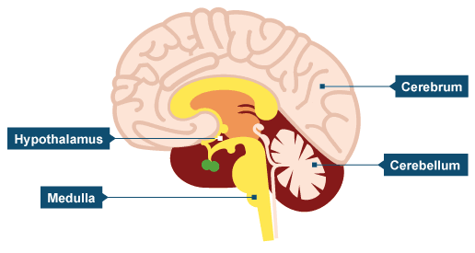 | - The brain controls complex behaviour. It is made of billions of interconnected neurones and has different regions that carry out different functions. The cerebrum which controls memory, personality and conscious thought, the cerebellum which controls balance and co-ordination of movement, the medulla which controls heart rate and breathing rate, the hypothalamus which is the regulating centre for temperature and water balance  Neuroscientists have been able to map the regions of the  brain to particular functions by studying patients with brain damage, electrically stimulating different parts of the brain and using MRI scanning techniques. The complexity and delicacy of the brain makes investigating and treating brain disorders very difficult.
4.5.2.3 The Eye (biology only)  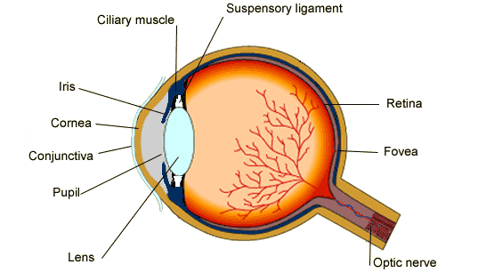  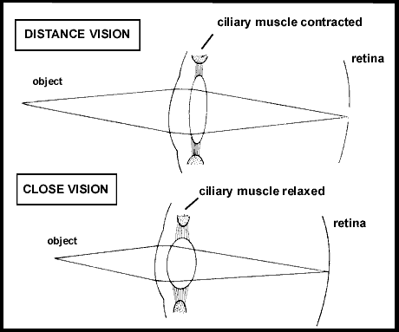 | The eye is a sense organ containing receptors sensitive to light intensity and colour.  Retina – light sensitive lining containing photoreceptor cells  optic nerve – bundle of sensory neurones  Sclera – the white of the eye, protective  Cornea – front part of the eye, tough outer coat  Iris – pigmented part of the eye, muscle alter the size of the pupil  ciliary muscles – control the thickness of the lens for focussing  suspensory ligaments – hold the lens in place  Accommodation is the process of changing the shape of the lens to focus on near or distant objects.  To focus on a near object:  • the ciliary muscles contract  • the suspensory ligaments loosen  • the lens is then thicker and refracts light rays strongly.  To focus on a distant object:  • the ciliary muscles relax  • the suspensory ligaments are pulled tight  • the lens is then pulled thin and only slightly refracts light rays.  Two common defects of the eyes are myopia (short sightedness) and hyperopia (long sightedness) in which rays of light do not focus on the retina.  • These defects are treated with spectacle lenses which refract the light rays so that they do focus on the retina.  • New technologies now include hard and soft contact lenses, laser surgery to change the shape of the cornea and a replacement lens in the eye.
4.5.2.4 Control of body temperature (biology only) | Body temperature is monitored and controlled by the thermoregulatory centre in the brain. The thermoregulatory centre contains receptors  sensitive to the temperature of the blood. The skin contains temperature receptors and sends nervous impulses to the thermoregulatory centre.  If the body temperature is too high, blood vessels dilate (vasodilation) and sweat is produced from the sweat glands. Both these mechanisms cause a transfer of energy from the skin to the environment.  If the body temperature is too low, blood vessels constrict (vasoconstriction), sweating stops and skeletal muscles contract (shiver).
4.5.3.1  Human endocrine system | The endocrine system is composed of glands which secrete chemicals called hormones into the bloodstream. Pituitary gland is the ‘master’ gland
4.5.3.2  Control of blood glucose concentration | Blood glucose too high, pancreas releases insulin. Glucose is moved into cells. Liver and muscle cells convert glucose glycogen for storage  Type 1 diabetes – the pancreas fails to produce enough insulin. Treat with insulin injections  Type 2 diabetes – body cells no longer respond to insulin. Commonly treat with a carbohydrate controlled diet and exercise. Obesity is a risk factor.  If blood glucose is too low, the pancreas releases glucagon, which converts glycogen into glucose which is released into the blood
4.5.3.3.  Maintaining water and nitrogen balance in the body (biology only) | Water leaves the body via the lungs during exhalation.  Water, ions and urea are lost from the skin in sweat.  There is no control over water, ion or urea loss by the lungs or skin.  Excess water, ions and urea are removed via the kidneys in the urine. If body cells lose or gain too much water by osmosis they do not function efficiently.  (HT only) The digestion of proteins from the diet results in excess  amino acids which need to be excreted safely. In the liver these amino  acids are deaminated to form ammonia. Ammonia is toxic and so it is  immediately converted to urea for safe excretion.  The kidneys produce urine by filtration of the blood and selective  reabsorption of useful substances such as glucose, some ions and  water.  (HT only) The water level in the body is controlled by the hormone ADH  which acts on the kidney tubules. ADH is released by the pituitary  gland when the blood is too concentrated and it causes more water  to be reabsorbed back into the blood from the kidney tubules. This is  controlled by negative feedback.  People who suffer from kidney failure may be treated by organ transplant or by using kidney dialysis.
4.5.3.4  Hormones in human reproduction | Oestrogen is the main female reproductive hormone.  Testosterone is the main male reproductive hormone.  Follicle stimulating hormone (FSH) causes maturation of the egg  Luteinising hormone (LH) stimulates release of the egg.  Oestrogen and progesterone are involved in maintaining the lining of the uterus
4.5.3.5  contraception | Oral contraceptives contain hormones to inhibit FSH, so no eggs mature. Injection, implant or skin patch of slow release progesterone inhibits maturation and release of eggs for months or years. Barrier methods e.g. condoms and diaphragms prevent sperm reaching the egg. Intrauterine devices (IUD) prevent implantation of the embryo in the womb, or release a hormone.  Spermicides kill sperm
4.5.3.6  Using hormones to treat infertility (HT ) | FSH and LH are contained in ‘fertility’ drugs. In vitro fertilisation (IVF) involves giving a mother FSH and LH to stimulate maturation of several eggs, the eggs are collected and fertilised by sperm in the laboratory. The fertilised eggs develop into embryos. These tiny balls of cells are inserted into the mother’s uterus. IT is emotionally and physically very stressful, has a low success rate, can lead to multiple births
4.5.3.6  Negative feedback (HT) | Adrenaline produced by the adrenal glands in times of fear or stress. It increases heart rate and boosts delivery of oxygen and glucose to the brain and muscles, preparing the body for ‘fight or flight’.  Thyroxine from the thyroid gland stimulates the basal metabolic rate, playing an important role in growth and development. Thyroxine levels are controlled by negative feedback

