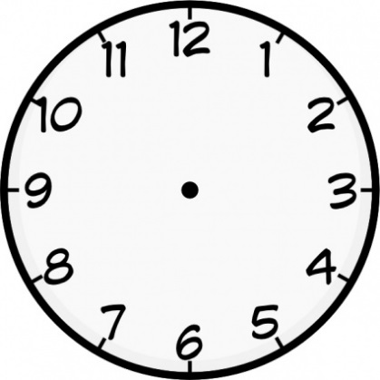

Write a response: ¿Te gusta ir a conciertos? *(Do you like to go to concerts?)*

Write a response: ¿Practicas algún deporte? Crees que es importante ser activo? *(Do you do a sport? Do you think it’s important to be active?)*

Write a response: ¿Qué tipo de comida prefieres? *(What type of food do you prefer?)*

Opinion phrases (about yourself and other people!)

I ate =

I drank =

I watched =

I listened to =

I played (a sport) =

I played (an instrument) =

I eat =

I drink =

I watch =

I listen to =

I play (a sport) =

I play (an instrument) =

Sports

Theme 1: Free-Time Activities

Positive and negative adjectives

Types of music and instruments

Types of film

Types of TV programme

Items of food and drink