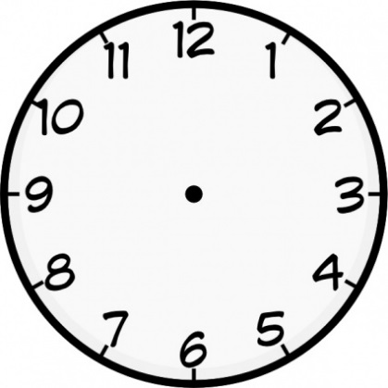

Write a response: ¿Preferirías vivir en la ciudad o en el campo? *(Would you prefer to live in the city or in the countryside?)*

I live – we live –

it is (description) - it is (location) –

they are (description) - they are (location) –

there is/there are -

I’m going to live –

if I won the lottery, I would live…

Adjectives to describe towns

I drank =

I watched =

I listened to =

I played (a sport) =

I played (an instrument) =

Shops

I drink =

I watch =

I listen to =

I play (a sport) =

I play (an instrument) =

Places in town (e.g. museum, square)

Rooms in the house

Types of house (e.g. flat) and areas (e.g. the coast)

Theme 2: Home, town, neighbourhood and region

Write a response: ¿Cómo es tu región? *(What is your region like?)*

Write a response: ¿Es importante tener una casa grande? *(Is it important to have a big house?)*

Opinion phrases (for your own and others’ opinions)

Furniture

Adjectives to describe homes