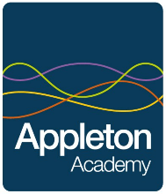
Linked Reading for Humanities

Here at Appleton, we love reading! You can learn so many new things from books, and the stories you read will stay with you for life!

Below, you will find some book recommendations that link to the subjects you will study in humanities.

Visit the link below to let us know what books you have already read, what you are currently reading, or what you’re going to read next!

https://forms.office.com/Pages/ResponsePage.aspx?id=0VteuAAfPE2Vg0EaO-D3Z3WLkU_dFYBPqW5RDmnjRR9UQ0s4T1lMWTJVNlo5NlYwWEJENDA2SENFWS4u

Geography
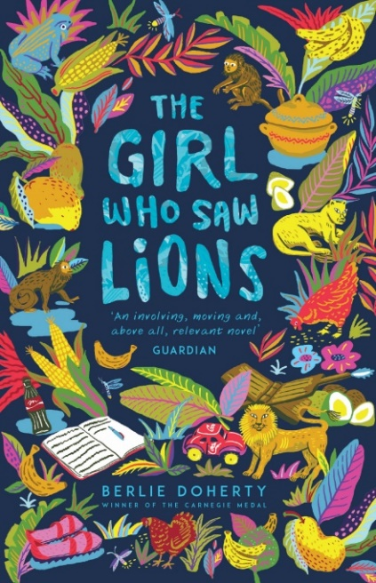 | The Girl Who Saw Lions  Berlie Doherty  Two girls, from very different places, are brought together in a tale of loss, courage and family.  Abela has lost everything, and now she must leave her home in Tanzania and flee to Britain.  Rosa's struggling to cope with her mum's wish to adopt a child.  When they are brought together, will Abela and Rosa ever be able to love one another like sisters?  From the Carnegie Medal-winning author Berlie Doherty, The Girl Who Saw Lions is a powerful and moving story, inspired by the author's visit to Africa. | 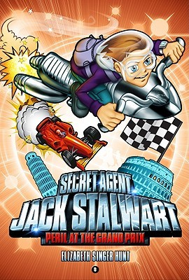 | Peril at the Grand Prix  Elizabeth Singer Hunt  The newest instalment of this series takes young readers along on Jack's most dangerous mission yet, as he travels to Italy in hopes of finding his missing brother on the eve of the biggest Italian car championship race.
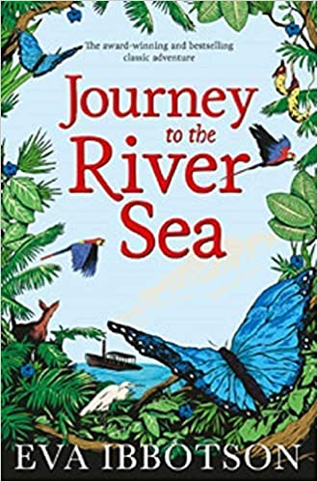 | Journey to the River Sea  Eva Ibbotson  It is 1910 and Maia, tragically orphaned at thirteen, has been sent from England to start a new life with distant relatives in Manaus, hundreds of miles up the Amazon. She is accompanied by an eccentric and mysterious governess who has secret reasons of her own for making the journey. Both soon discover an exotic world bursting with new experiences in Journey to the River Sea, Eva Ibbotson's highly colourful, joyous adventure. | 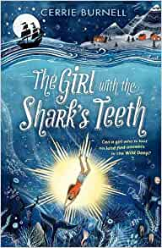 | The Girl with the Shark’s Teeth  Cerrie Burnell  Minnow is different from the other girls in her town and there's plenty to set her apart: the blossom of pale scars which lie beneath Minnow's delicate ears, the fact that she has an affinity with the water which leaves people speechless, and that once - she is sure - in deep, deep water, her body began to glow like a sunken star.  When her mum gets into trouble and is taken from their boat in the dead of night, Minnow is alone with one instruction: sail to Reykjavik to find your grandmother, she will keep you safe. Minnow has never sailed on her own before, but the call of the deep is a call she's been waiting to answer her whole young life.  Perhaps a girl who is lost on land can be found in the Wild Deep.

History
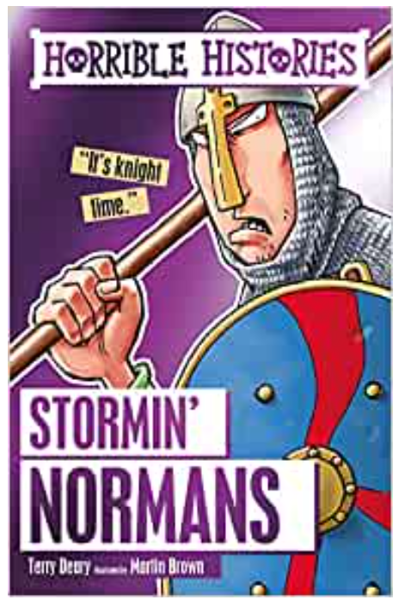 | Stormin’ Normans: Horrible Histories  Terry Deary  Readers can discover all the foul facts about the STORMIN' NORMANS, including why Norman knights slept with a dolly, which pirate hung up his eye-patch and became a saint and why Crusader ships were defended with barrels of pee. | 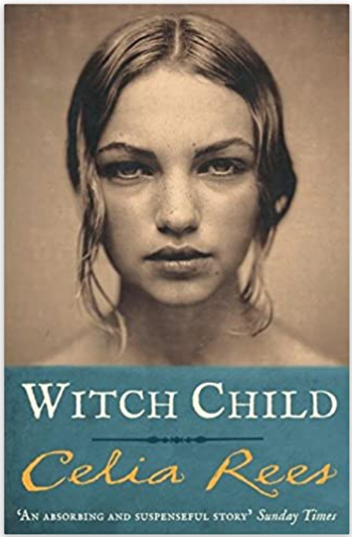 | Witch Child  Celia Rees  When Mary sees her grandmother accused of witchcraft and hanged for the crime, she is silently hurried to safety by an unknown woman. The woman gives her tools to keep the record of her days - paper and ink. Mary is taken to a boat in Plymouth and from there sails to the New World where she hopes to make a new life among the pilgrims. But old superstitions die hard and soon Mary finds that she, like her grandmother, is the victim of ignorance and stupidity, and once more she faces important choices to ensure her survival.
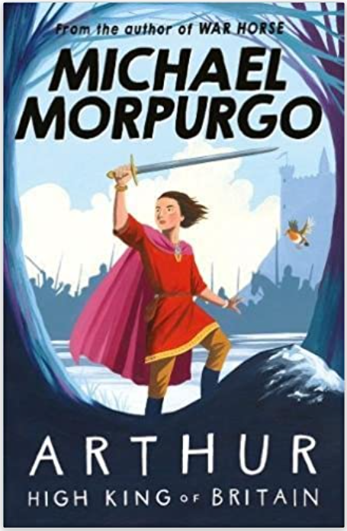 | Arthur: High King of Britain  Michael Morpurgo  An enchanting take on the legend of King Arthur from War Horse author and former Children's Laureate, Michael Morpurgo.  Marooned on a sandbank, a boy faces certain death. With the sea closing in and the current about to drag him to a watery grave, his final wish is to see heaven. Waking in a strange bed, the boy meets an old man sitting by the fire with his dog. It is Arthur, the great warrior king of legend, and from his lips the boy hears of Camelot, chivalry, magic, evil and betrayal. | 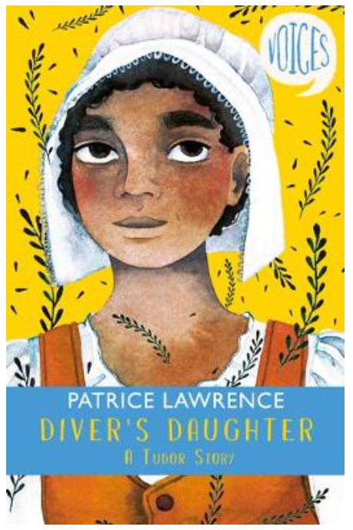 | Diver’s Daughter: A Tudor Story  Patrice Lawrence  Voices: Diver's Daughter - A Tudor Story explores the life of a young West African girl, Eve, living with her mother in the Southwark slums of Elizabethan London. When they hear from a Mary Rose survivor, George Symon, that one of the African free-divers who salvaged its treasures is alive and well and living in Southampton, mother and daughter agree to try to find him. But will the pair survive when George arrives to claim his 'share' of the riches? Will Eve overcome her fear of water to rescue her mother from the sea?
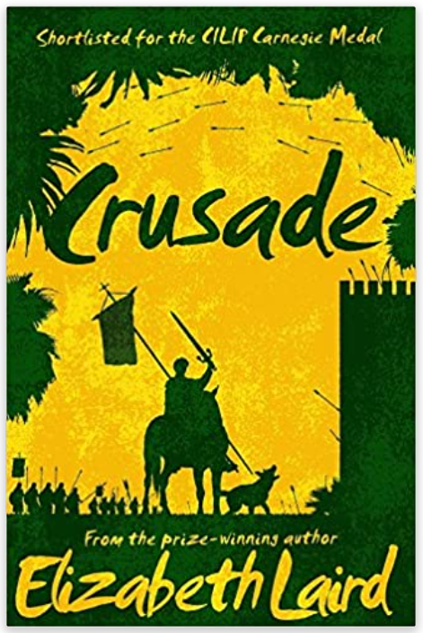 | Crusade  Elizabeth Laird  Two boys. Two faiths. One unholy war.  When Adam's mother dies unconfessed, he pledges to save her soul with dust from the Holy Land. Employed as a dog-boy for the local knight, Adam grabs the chance to join the Crusade to reclaim Jerusalem. He burns with determination to strike down the enemy.  Salim, a merchant's son, is leading an uneventful life in the port of Acre - until news arrives that a Crusader attack is imminent. To keep Salim safe, his father buys him an apprenticeship with an esteemed, travelling doctor. But Salim's employment leads him to the heart of Sultan Saladin's camp - and into battle against the barbaric and unholy invaders. | 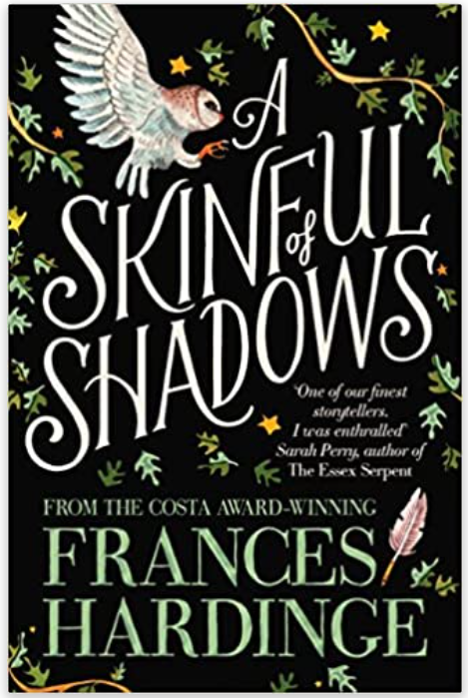 | A Skinful of Shadows  Frances Hardinge  When a creature dies, its spirit can go looking for somewhere to hide. Some people have space inside them, perfect for hiding.  Makepeace, a courageous girl with a mysterious past, defends herself nightly from the ghosts which try to possess her. Then a dreadful event causes her to drop her guard for a moment.  And now there's a ghost inside her. The spirit is wild, brutish and strong, but it may be her only defence in a time of dark suspicion and fear. As the English Civil War erupts, Makepeace must decide which is worse: possession – or death.
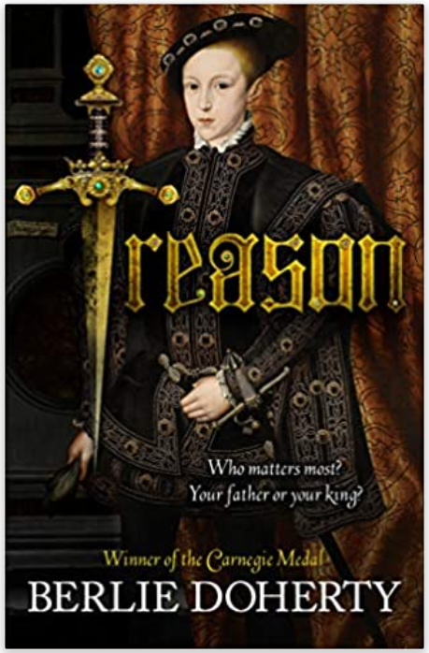 | Treason  Berlie Doherty  Will Montague is a page to Prince Edward, son of King Henry VIII. As the King's favourite, Will gains many enemies in Court. His enemies convince the King that Will's father has committed treason and he is thrown into Newgate Prison. Will flees Hampton Court and goes into hiding in the back streets of London.  Lost and in mortal danger, he is rescued by a poor boy, Nick Drew. Together they must brave imprisonment and death as they embark on a great adventure to set Will's father free. | 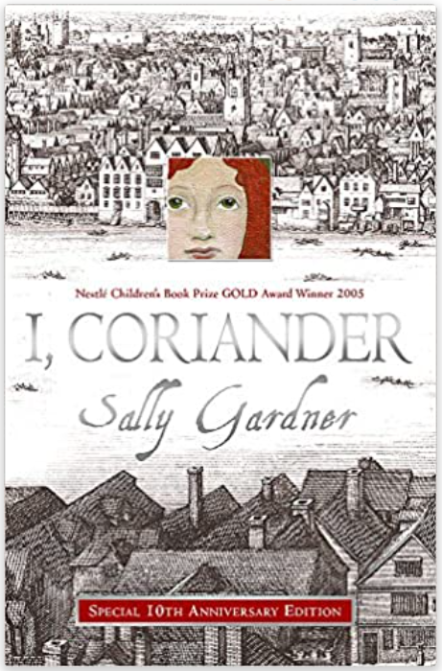 | I, Coriander  Sally Gardner  The story is told by Coriander, daughter of a silk merchant in 1650s London. Her idyllic childhood ends when her mother dies and her father goes away, leaving Coriander with her stepmother, a widow who is in cahoots with a fundamentalist Puritan preacher. She is shut away in a chest and left to die, but emerges into the fairy world. When she returns, charged with a task that will transform her life, she is seventeen.  This is a book filled with enchantments that contrast with Coriander's life in the real world. With its brilliantly realised setting of old London Bridge, and underpinned by the conflict between Royalists and Puritans, it is a terrific page-turner, involving kidnapping, murder and romance.

Religious Education
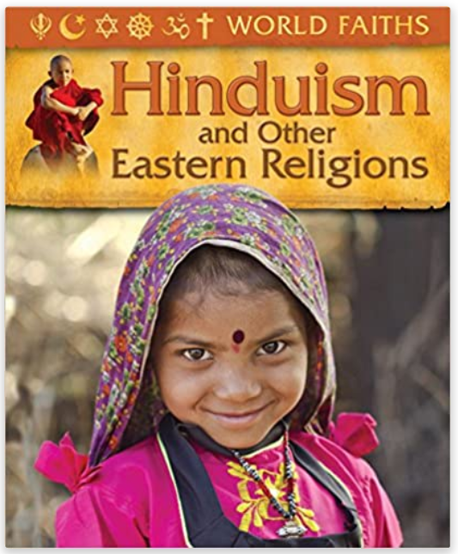 | World Faiths: Hinduism and Other Religions  Trevor Barnes  In today’s world, where religious divides and cultural differences so often have tragic consequences, a sound understanding of the belief systems and practices of other peoples and cultures is essential. The four books in the World Faiths series: Christianity; Hinduism and Other Eastern Religions; Islam and Judaism, offer a simple and child-friendly introduction to religion around the world. The history and origins of each religion are explained, along with information about their calendar and festivals; places of worship; religious practices and their place in modern society. | 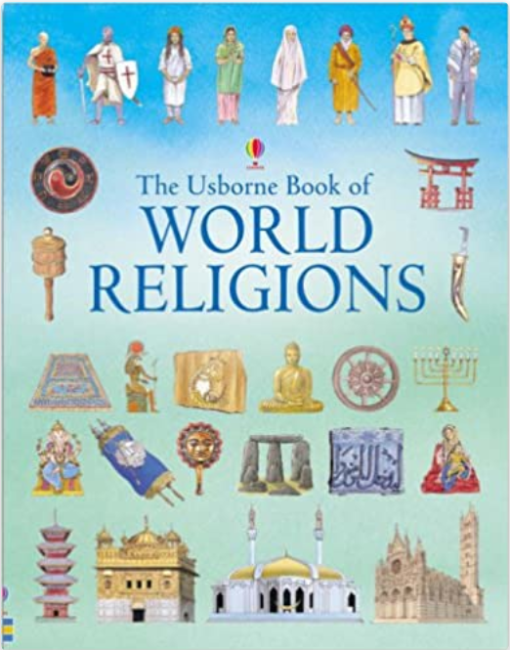 | The Usborne Book of World Religions  Susan Meredith  This thought-provoking exploration of an important subject covers all the major world religions, as well as some less well-known faiths. Understanding the differences between people’s religious beliefs is now more important than ever. Each religion is brought vividly to life with photographs, detailed illustrations and straightforward, informative text. Includes maps, time chart and glossary.
 | Religion  DK Eyewitness  DK Eyewitness Religion is full of amazing photographs that allow your child to escape into the unique "eyewitness" view of the beliefs around the globe.  Take a look at the world of faith and religion with your child. Help them to discover and understand the beliefs in the Gods of the Nile, the Greek Gods and take a look at religion in the modern world. Plus there's the giant pull-out wall chart that can be used decorate their room.  Great for projects or just for fun, make sure your child learns everything they need to know about religion. | 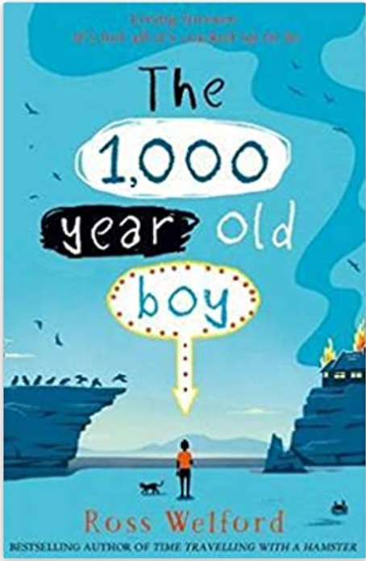 | The 1000 Year Old Boy  Ross Welford  There are stories about people who want to live forever. This is not one of those stories. This is a story about someone who wants to stop…  Alfie Monk is like any other nearly teenage boy – except he’s 1,000 years old and can remember the last Viking invasion of England. Obviously, no one believes him.  So when everything Alfie knows and loves is destroyed in a fire, and the modern world comes crashing in, Alfie embarks on a mission to find friendship, acceptance, and a different way to live… which means finding a way to make sure he will eventually die.

PSHCE
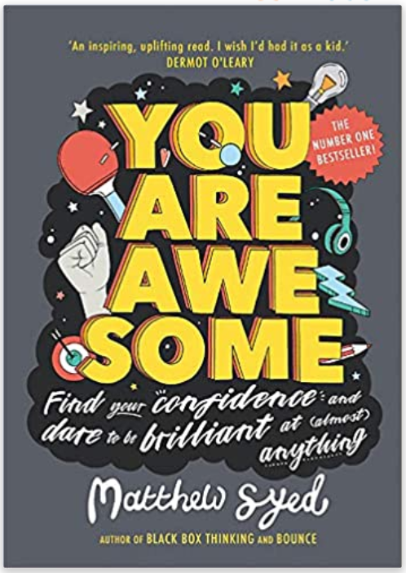 | You Are Awesome  Matthew Syed  I'm no good at sport ... I can't do maths ... I really struggle with exams ... Sound familiar?  If you believe you can't do something, the chances are you won't try. But what if you really could get better at maths, or sport or exams? In fact, what if you could excel at anything you put your mind to?  You Are Awesome can help you do just that. The first children's book from Times journalist, two-time Olympian and best-selling mindset author Matthew Syed, it uses examples of successful people from Mozart to Serena Williams to demonstrate that success really is earned rather than given, and that talent can be acquired. With hard work and determination, practice, self-belief and a Growth Mindset, there's no reason why anyone can't achieve anything. | 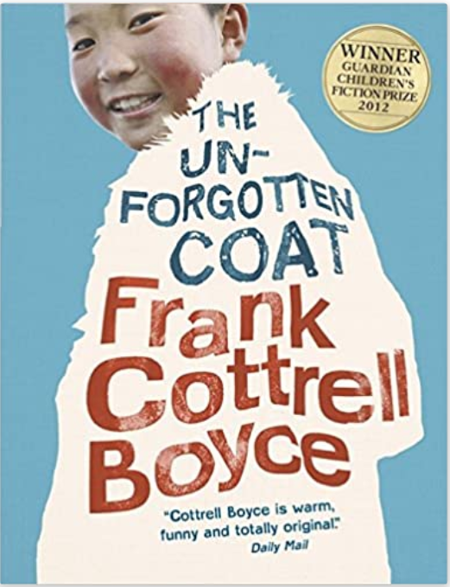 | The Unforgotten Coat  Frank Cottrell Boyce  From the award-winning author of Millions comes a story of friendship in the midst of adversity. Winner of the 2012 Guardian Children's Fiction Prize, this magical and poignant book is enriched by stunning and atmospheric Polaroid photos.  Two refugee brothers from Mongolia are determined to fit in with their Liverpool schoolmates, but bring so much of Mongolia to Bootle that their new friend and guide, Julie, is hard-pressed to know truth from fantasy. Told with the humour, warmth and brilliance of detail which characterizes Frank Cottrell Boyce's writing, readers will be transported from the streets of Liverpool to the steppe of Mongolia.
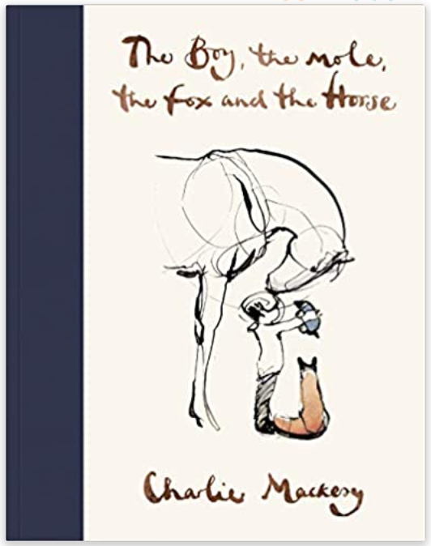 | The Boy, the Mole, the Fox and the Horse  Charlie Macksey  The Sunday Times Bestseller and New York Times Bestseller. A book of hope for uncertain times.  Enter the world of Charlie's four unlikely friends, discover their story and their most important life lessons.  The conversations of the boy, the mole, the fox and the horse have been shared thousands of times online, recreated in school art classes, hung on hospital walls and turned into tattoos. In Charlie's first book, you will find his most-loved illustrations and some new ones too. | 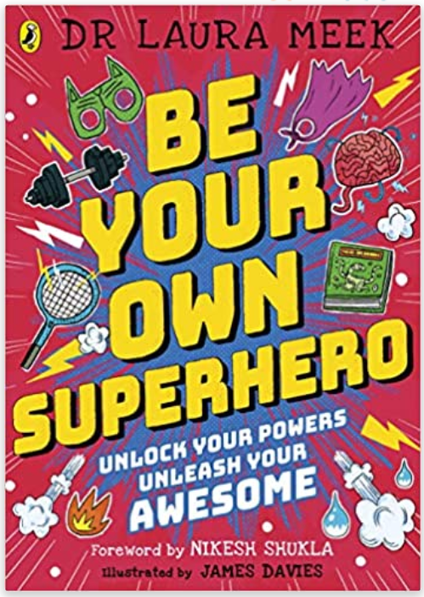 | Be Your Own Superhero  Dr. Laura Meek  Is anxiety your arch-enemy?  Are your emotions hulking out?  Is low confidence your kryptonite?  Then this book is for you. From developing their telepathic powers (empathy and listening skills), to controlling fire (anger) and water (anxiety), this book will take children through a series of fun activities designed to help them feel in control of their lives, happier and more confident.  We're all superheroes. Sometimes we just need a bit of help finding our powers.

