Meet the team

Maths Team | About Us
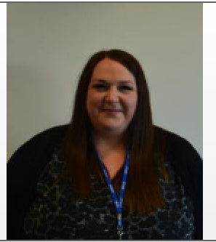  Mrs Bateman | Hi, I am Mrs Bateman. I am the Assistant Headteacher in charge of maths at Appleton Academy. I have worked here for 3 years.  I studied Maths and education at Liverpool John Moores University.  My favourite topics to teach in maths are trigonometry and solving equations. I also love code breaking!
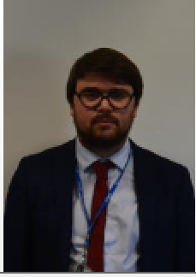  Mr Taylor | Hi I’m Mr Taylor and I can’t wait to meet you and teach you maths at Appleton Academy. My favourite topics of maths are geometry and algebra!
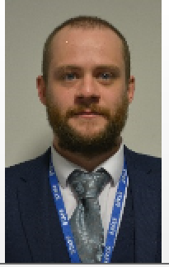  Mr Fox | Hi, my name is Mr Fox and I have worked at Appleton Academy for four years. I am looking forward to meeting you all in September.  I studied secondary education and mathematics at Sheffield Hallam University.  My favourite area of maths is decision maths at A level.
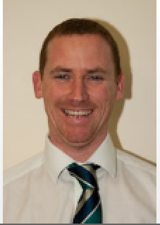  Mr Gerrett | Hi, my name is Mr Gerrett. I studied Business Management at Leeds Metropolitan University.  I have worked at Appleton Academy for 20 years. I first started teaching business studies and now teach mathematics. I have loved teaching coordinates and bearings as I enjoying drawing in maths.
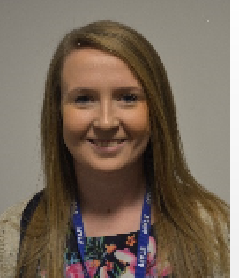  Miss Enright | Hi, my name is Miss Enright. I am the assistant subject leader in maths.  I studied English and Sport Science at Loughborough University.  I have worked at Appleton Academy for 5 years. I love teaching problem solving and helping my students to solve multi-step questions.
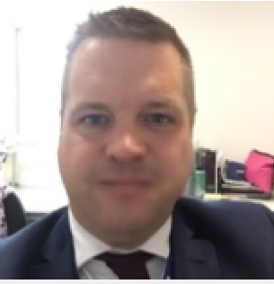  Mr Ayres | Hi, my name is Mr Ayres. I am one of the deputy headteachers at Appleton Academy.  I studied Music at Huddersfield University.  I like using multilink cubes and other maths equipment to make the lessons fun. My favourite topic in maths is standard form.  I have worked at Appleton for 7 years.
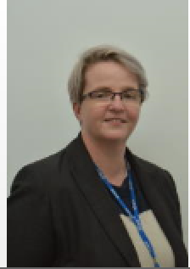  Miss Whitehead | Hi, my name is Miss Whitehead. I am one of the deputy headteachers at Appleton Academy. I have worked here for 2 years.  I studied Mathematics at Trinity and All Saints University College Leeds.  My favourite part of maths is circle theorems.
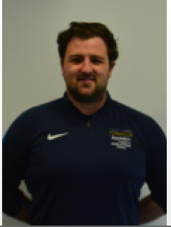  Mr Kerrigan | Hi, my name is Mr Kerrigan and I have worked at Appleton Academy for 3 years.  Although I am in charge of PE, I also teach maths. My favourite topics to teach are collecting like terms and solving simultaneous equations.

