Meet the Humanities Team!

Geography
Mrs. Broadhurst
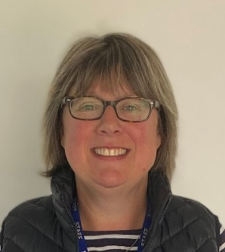
Mrs. Broadhurst teaches geography and is passionate about her subject. She has taught geography for many years and in a number of different schools before she joined Appleton Academy nine years ago. Apart from teaching geography, she is an Assistant Headteacher responsible for teaching, learning and curriculum, and spends some of her time at University training new geography teachers. When she is not teaching she loves to spend her time outdoors, she is a keen cyclist and hill walker. In her spare time she also enjoys taking her dog for lovely walks along the coast.

Miss Tranter
Miss Tranter has been teaching geography at Appleton Academy for a year now. She believes geography is an amazing subject because it involves everyone and explores the world around us. She is looking forward to welcoming students in the new school year and sharing her love of geography. In her spare time she enjoys watching competitive sports, as well as, occasionally playing netball herself. She’s keen to spend as much time as possible outdoors either running, walking or cycling. Her favourite thing to do is going to the seaside and eating fish and chips.

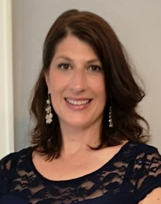
Mrs. Tynan
Mrs. Tynan teaches geography and is looking forward to working with students at Appleton on their geography journey. She has held diverse positions in private industry including geologist, project manager and business owner before joining Appleton Academy two years ago. She loves all things geography and her enthusiasm for the subject grows every year. When she is not teaching she loves to spend time with her family as an involved football mum and ballet mum. She loves to cook, bake, garden, read and most of all loves to laugh. Mrs. Tynan is looking forward to the next chapters ahead of exciting life at Appleton Academy.

History

Miss Boyle
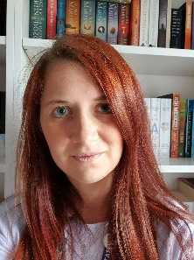
Miss Boyle has been teaching history and English at Appleton for eight years now and hopes to encourage her students to love the subjects as much as she does. She studied History at the University of York, then Medieval Studies at the University of Manchester, where she was able to work with real books from the fifteenth century! She especially loves the social, cultural and religious aspects of medieval history, and has developed a recent fascination with the Tudors. She has participated in medieval re-enactments, making medieval-style clothing and training with a replica Viking broadsword. In her spare time, Miss Boyle enjoys reading, writing and running.

Mrs. France
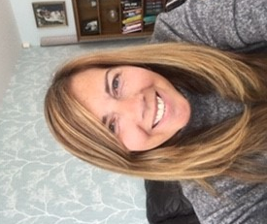
Mrs. France has been at Appleton for four years and enjoys teaching her students very much. Mrs France has a passion for all history but in particular the history surrounding slavery and empire, along with British modern history in the twentieth century. She loves reading, running and singing, so expect a tune or two! Mrs. France also runs Appleton Academy Community Ambassadors, an elite group of representatives for our school, the Anti-Bullying Ambassadors, and the Y9 and Y10 Appleton Heroes. She will actively encourage you to become involved in these fantastic groups.

Mr. Paton
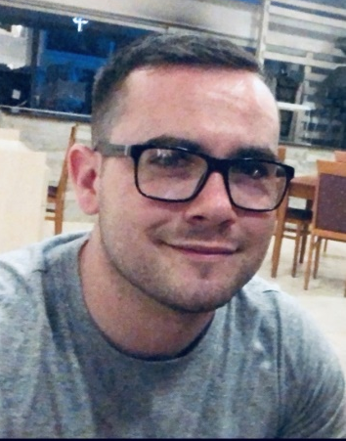
Mr. Paton has been teaching history at Appleton for three years now and hopes that the students who study at the Academy leave the school with a better understanding of the world that we live in today. He studied History and American Studies at York St. John University and loves medieval history, especially the Crusades! In Mr. Paton’s spare time he enjoys Rugby League, going to the gym and taking long walks.
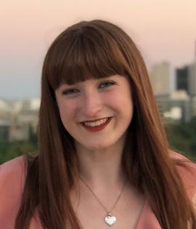
Miss Raistrick
Miss Raistrick has been at Appleton for two years; she loves history and enjoys passing on this enthusiasm for the past to students. She studied History at the University of Leeds, where she discovered her favourite area of history to be modern history – she especially loves investigating things from the 20th century! Miss Raistrick loves to travel and explore new places, but also enjoys reading, cooking and getting involved in crafty projects. At school, she also runs a weekly history afterschool club, where pupils can take part in various activities to research areas of history that they are interested in.

RE/PSHCE

Mr. Martin
Mr. Martin has been teaching RE at Appleton for a number of years now. He also teaches PSHCE. He studied Theology and Philosophy at Leeds University alongside an Honours degree in secondary teaching. He really loves the diverse nature of the subjects, talking and debating about all the different backgrounds we have here in our country. He especially likes the ethical issues studied throughout all year groups and loves introducing new theories for students to test out at home. Mr. Martin is also a Head of Year at Appleton and looks forward to seeing you all in September.

