Paper 1 Writing
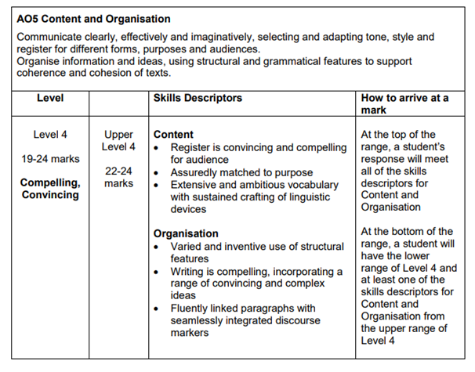
Success Criteria:
Formal register
Matched to the purpose - laid out like an article
Sophisticated vocab
Language devices
Structural features
Original ideas
Paragraphs linked together with discourse markers
Range of punctuation
SPAG

Include:
Language devices
Metaphors, similies, onomatopoeia, descriptive vocabulary
Structural devices
Paragraph and sentence lengths for effect

Make sure every paragraph has a shift in focus.

