Paper 2 Q5 Reading
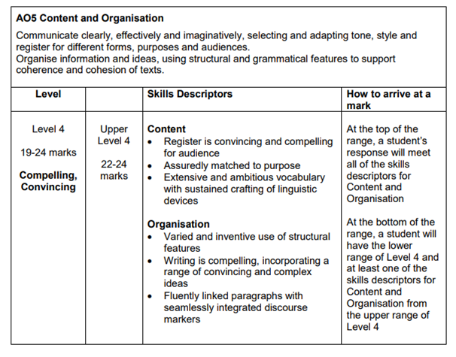
Success Criteria:
- Formal register
- Matched to the purpose - laid out like an article
- Sophisticated vocab
- Language devices
- Structural features
- Original ideas
- Paragraphs linked together with discourse markers
- Range of punctuation
- SPAG

Include at least 7 or 8 things from the persuasive device mat.

