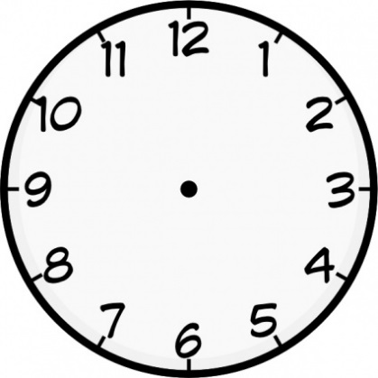

Forms of the verb ‘tener’ (to have)

Forms of the verb ‘ser’ (e.g. ‘I am’)

Giving other people’s opinions

Connectives

Qualifiers (very, quite…)

Other words for ‘because’

Opinion Phrases

Frequency phrases

Verbs to describe relationships (me llevo bien…)

Adjectives to describe personalities

Describing Appearances

Members of the family

Theme 1: Relationships with family and friends