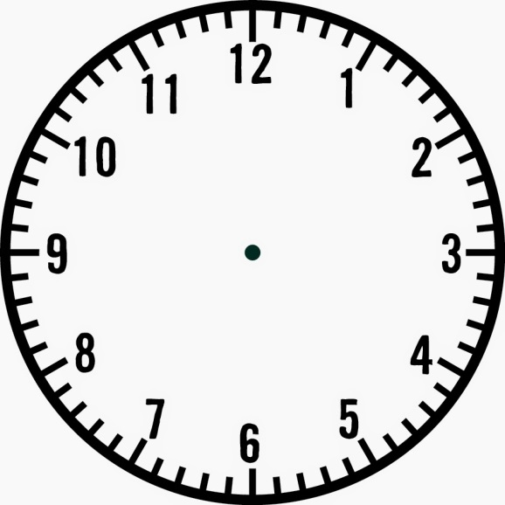

Catholicism and Protestantism and Elizabeth’s Religious Settlement

Early Issues: the Succession, Ireland, Taxation and foreign policy

The Babington Plot and the Execution of Mary Queen of Scots

Elizabeth’s Suitors

Mary Queen of Scots

The Northern Rebellion

Puritanism

The Throckmorton and Ridolfi Plots

The Privy Council

Elizabeth’s Early Life

The Court

Parliament

**Elizabeth: Topic 1**

**Revision Clock**