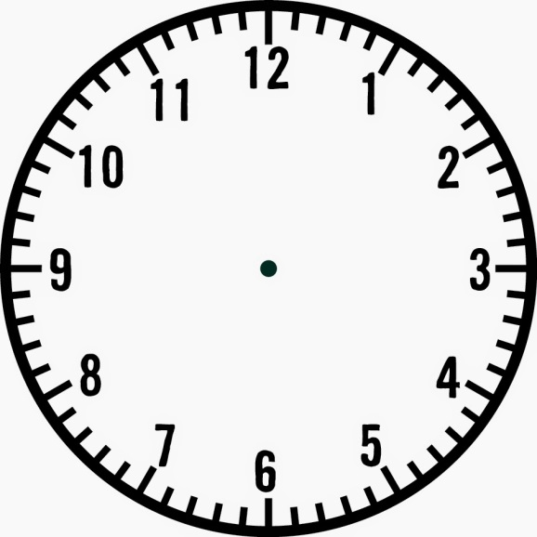

Poverty: Solutions

Architecture

Poverty: Impact

Poverty: Causes

The Rise of the Gentry

How far was Elizabeth’s reign a Golden Age?

Exploration: Key Figures

Exploration: Positive Impact

Exploration: Negative Impact

Fashion and Art

Theatre

Literature and Music

**Elizabeth: Topic 2**

**Revision Clock**