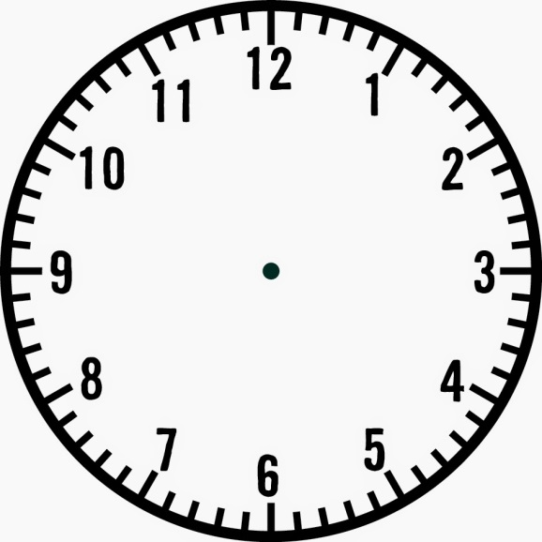

The Armada: Reasons for English victory

The Armada: Preparations

The Dutch War and the Treaty of Nonsuch

The Armada: Ship Design

Privateers

Cadiz

Religious Differences

The Armada: Aftermath

The Armada: Leadership

The Armada: Key Events

Philip II

Drake’s circumnavigation of the globe

**Elizabeth: Topic 3**

**Revision Clock**