13

Section B: Writing

You are advised to spend about 45 minutes on this section.
Write in full sentences.
You are reminded of the need to plan your answer.
You should leave enough time to check your work at the end.
_________________________________________________________________________

05 An online competition for story writing is being held and you have decided to enter.

Write a description as suggested by this picture:

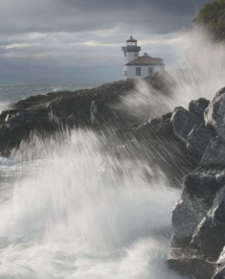

Write a story about a time when you felt unsure or challenged. Focus on the thoughts and feelings you had at the time.

(24 marks for content and organisation
16 marks for technical accuracy)
[40 marks]
_______________________________________________________________________________________________________________________________________________________________________________________________________________________________________________________________________________________________________________________________________________________________________________________

