13

Section B: Writing

You are advised to spend about 45 minutes on this section.
Write in full sentences.
You are reminded of the need to plan your answer.
You should leave enough time to check your work at the end.
_________________________________________________________________________

05 You are going to enter a creative writing competition.

Your entry will be judged by a panel of people of your own age.

Write a description as suggested by this picture:

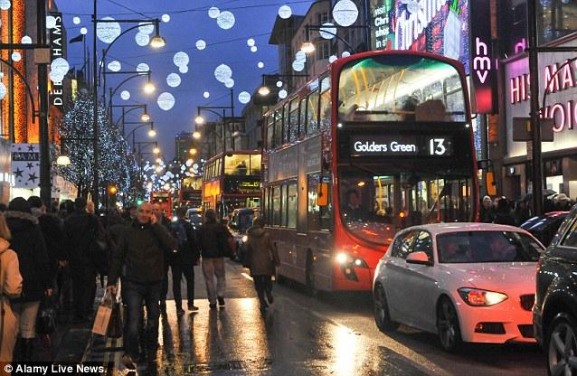

(24 marks for content and organisation
16 marks for technical accuracy)
[40 marks]

_______________________________________________________________________________________________________________________________________________________________________________________________________________________________________________________________________________________________________________________________________________________________________________________

