Year 11
Revision Pack
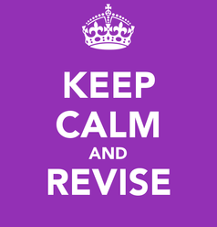

Name :
Paper 1:
USA Opportunity and Inequality 1920 – 1973
Conflict and Tension 1918 – 1939

Paper 2:
Britain: Migration, Empires and the people c.790 to the present day
Elizabethan England 1568 – 1603

Useful websites:
www.bbcbitesize.co.uk (AQA exam board)
www.johndclare.net
http://www.aqa.org.uk/subjects/history/gcse/history-8145/assessment-resources
PAPER 1 Understanding the Modern World
1 hour 45 mins 80 marks
USA : Opportunity and Inequality 1919 - 1973 | Conflict and Tension 1918-1939
Question 1: 4 marks AO4 5 mins  How do these interpretations differ?  - How the two written interpretations differ using the content of the interpretations.  - 2 explanations need to be given. | Question7: 4 marks AO3 5 mins  Source analysis  - The source will either support or oppose something.  - It could either be a cartoon or a written statement  - 2 points need to be made – use knowledge to comment on the content; make an inference to draw a simple analysis. Can also comment on the provenance of the source.
Question 2: 4 marks A04 5 mins  Why do these interpretations differ?  - This is about who wrote the source and why their opinions might differ.  - Students need to comment on who wrote the interpretations and think about why this might affect their opinions.  - Give at least 2 reasons for the differences such as date, place, beliefs, access to information, audience, motives and purpose. | Question 8: 12 marks AO3 15 mins  Which source is most useful/utility?  - 2 sources, can be both visual or text  - Must look at provenance  - Deal with each source separately, no need to say which is more useful.  - Comment on 2/3 aspects of the sources –using knowledge to analyse the content of the sources (i.e. what is true & therefore useful – link to historical context).  - Also comment on the provenance to decide how useful the sources are. (i.e. are they reliable – if not, why not?)  - Limitations of the sources, what else do you know that is not in the sources?
Question 3: 8 marks A04 10 mins  Which is the most convincing interpretation?  - These will be a valid interpretations: pictorial or text  - Do not question the provenance  - Write about both interpretations.  - Pick out key points and use their knowledge and contextual understanding to explain which interpretation is the most convincing one. | Question 9: 8 marks A01 AO2 10 mins  Write an account  - Give 2 reasons.  - Need to show knowledge of the sequence of events – so a chronological answer  - Need to show how events led to a big problem. use the wording in the question
Question 4: 4 marks A01 A02 5 mins  Describe in depth  - Identify 2 problems, issues, difficulties, features or solutions  - Show understanding of each one identified | Question 10: 16 marks 4 SPAG A01 AO2 20 mins  Essay question: How far do you agree?  - Explain 2/3 factors.  - This must include the point in the question  - Judgement must be sustained – i.e. well explained and the different factors compared
Question 5 8 marks AO1 AO2 10 mins
In what ways…Explain your answer
- Identify at least 2 examples and use PEE to structure answer
Question 6: 12 marks AO1 AO2 15 mins
Explain essay question in bullet points
- Identify and explain the impact of two reasons for a key event, development, individual and or group.
- Cover both bullet points well to reach Level 3.
- To reach Level 4 a sustained judgement needs to be made. Two factors could be linked/compared in order to do this.

Paper 1: Unit 1
USA Opportunity and inequality 1920 - 1973
Part One: The Boom
The boom | Learning Checklist
Why was there an economic boom in the 1920s?
Henry Ford
Groups who didn’t benefit
The stock market and buying on the margin
Cycle of prosperity
Social and cultural developments | Learning Checklist
Roaring twenties : Flappers, music, cinema and sports
Groups who did not experience the Roaring twenties
Divided society | Learning Checklist
Prohibition: what was it and why did it fail?
Al Capone
African Americans in the 1920s
The KKK
The Red Scare and Sacco and Vanzetti
Part Two : Depression and New Deal
American Society During the Depression | Learning Checklist
What caused the Wall Street Crash?
Unemployment
Farmers
Businessmen
Hoover’s Responses and Unpopularity
Roosevelt’s Election as President
First 100 days as President
The Effectiveness of the New Deal on Different Groups in Society | Learning Checklist
Alphabet agencies
Successes of the New Deal
Opposition to the New Deal
Roosevelt’s Contributions as President
Popular Culture
The Impact of the Second World War | Learning Checklist
America’s Economic Recovery
Land Lease
Exports
Social Developments, Including Experiences of
African-Americans and Women
Part Three : Post War America
Post war society | Learning Checklist
The 1950s : Prosperity
Rock and Roll
McCarthyism
Racial tension and civil rights | Learning Checklist
Civil Rights movement : Peaceful protest
Civil rights movement : Non-peaceful
What did Civil Rights achieve?
America and the ‘Great Society’ | Learning Checklist
Kennedy’s ‘New Frontier’
Johnson’s ‘New Frontier’
Feminism

Keywords
Write a definition for the key words and add in any statistics or additional information that you can. Remember if you are using the internet to help you, you must be specific towards the course and time period.
African-American
Anarchist
Assembly line
Billboard
Bill of Rights
Blacklist
Bootlegging
Boycott
Breadline
Buying on the margin
Chaperone
Civil Rights movement
Civil Rights Act
Communism
Congress
Constitution
Consumer goods
Containment
Democratic party
Direct action
Dividend
Dust bowl
Economic boom
Federal government
Feminist movement
Flapper
Freedom ride
Great Depression
Great society
Hire purchase
Hobo
Hooverville
HUAC
Import Duty
Isolationist
Jazz
Laissez-faire
Lend Lease
Loyalty Programme
Lynch
Mall
Mass production
McCarthyism
Militant
Moonshine
Neutrality
New Frontier
Organised Crime
Over production
Persecution
Popular culture
Racketeering
Radical
Relief
Reform
Recovery
Republican Party
Rugged Individualism
Segregation
Separatism
Share
Sharecropper
Shareholder
Sit-in
Speak-easy
Speculation
State Government
Stock market
Supremacy
Supreme Court
Tariff
Trade union
Under consumption

Practice questions
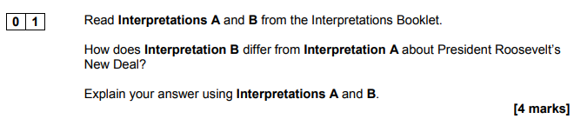
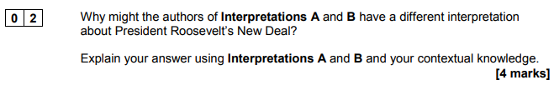
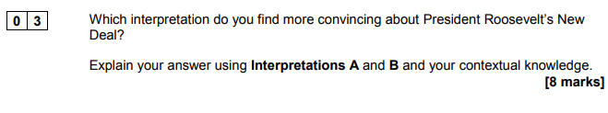
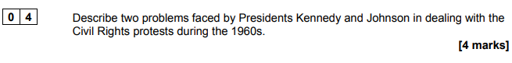
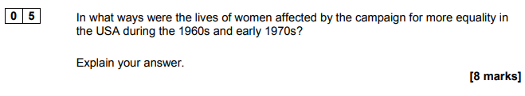
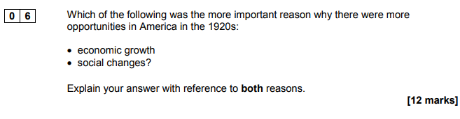
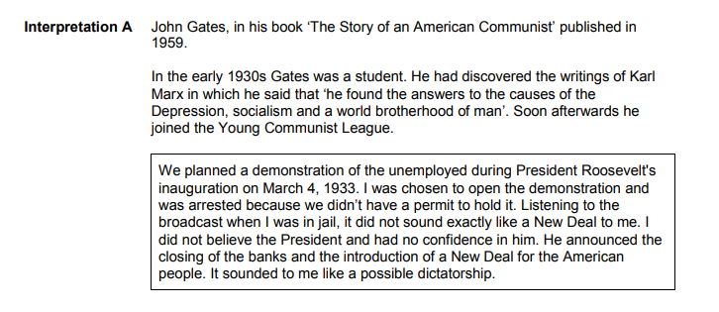
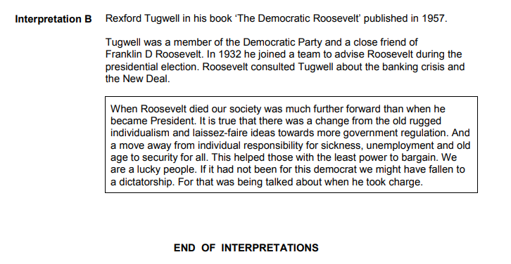

Paper 1: Unit 2
Conflict and tension, 1918 - 1939
Part One: Peace-making
Aims of the peace keepers | Learning Checklist
Clemenceau
Lloyd George
Woodrow Wilson
Disagreements and compromise
Versailles | Learning Checklist
Land
Arms
Money
Blame
German Reaction
Allies reaction
Part Two: League of Nations
Structure of the League | Learning Checklist
Formation and covenant
Membership
Organisation
Weaknesses of the League
League in the 1920s | Learning Checklist
Successes of the League in the 1920s (x2)
Failures of the League in the 1920s (x2)
Diplomacy outside of the League | Learning Checklist
Kellogg-Briand Pact
Locarno Treaties
League in the 1930s | Learning Checklist
The effects of the Depression on the League
Manchuria – Events
Manchuria – Consequences
Abyssinia – Events
Abyssinia – Consequences
Part Three : Road to War
Foreign Policy | Learning Checklist
Hitler’s aims for his foreign policy
Rearmament and conscription
The Stresa Front
Actions which led to war | Learning Checklist
Dollfuss Affair – events
Dollfuss Affair – Consequences
The Saar Coalfields – Events
The Saar Coalfields – Consequences
The Rhineland – Events
The Rhineland – Consequences
Anschluss – Events
Anschluss – Consequences
Sudetenland – Events
Sudetenland – Consequences
Czechoslovakia – Events
Czechoslovakia – Consequences
Nazi – Soviet Pact – Details
Nazi – Soviet Pact – Consequences
Invasion of Poland
Appeasement

Keywords
Write a definition for the key words and add in any statistics or additional information that you can. Remember if you are using the internet to help you, you must be specific towards the course and time period.
Allies
Anschluss
Appeasement
Armistice
Assembly (League of Nations)
Big Three
Benes
Collective Security
Conscription
Council (League of Nations)
Covenant of the League of Nations
Demilitarised
Diktat
Disarmament
Foreign policy
Haille Selassie
Hyperinflation
Idealist
Isolationism
Lebensraum
Luftwaffe
Mandate
Military force
Moral condemnation
Mukden Incident
Pact
Plebiscite
Remilitarise
Rhineland
Reparations
Sanctions
Saar Coalfields
Secretariat
Self-determination
Swastika
Trade sanctions (economic sanctions)
Unanimous
Veto
Wall Street Crash
War Guilt (Clause 231)

Practice questions

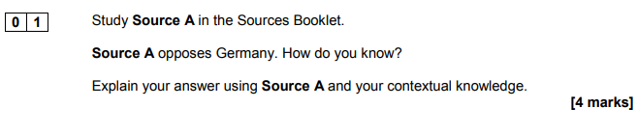
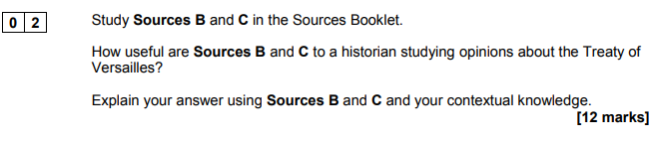
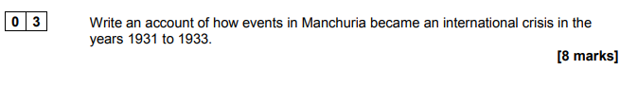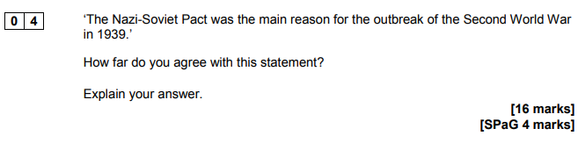

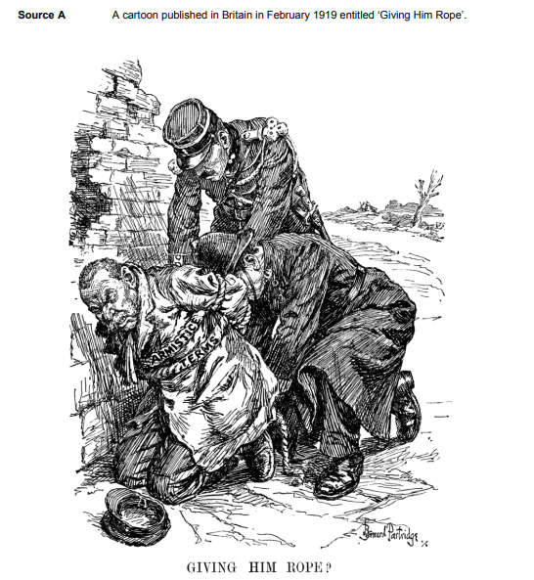

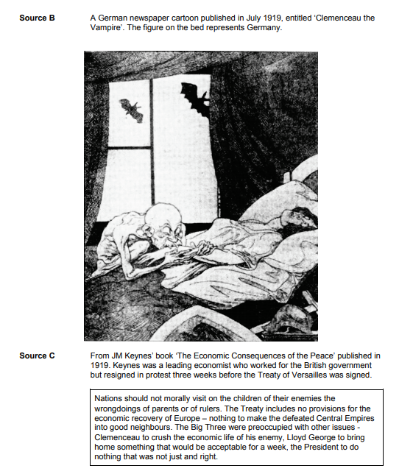

PAPER 2 Shaping the Nation
1 hour 45 mins 80 marks
Migration and Empire | Elizabethan England 1568-1603
Question 1: 8 marks AO3 10 mins  How useful is this source?  - 1 source, can be both visual or text  - Comment on 2/3 aspects of the source –using knowledge to analyse the content of the source (i.e. what is true & therefore useful – link to historical context).  - Also comment on the provenance to decide how useful the source is. (i.e. is it reliable – if not, why not?)  - Limitations of the source, what else do you know that is not in the source? | Question 5: 8 marks AO4 10 mins  How convinced are you by this interpretation?  - This will be a valid interpretation pictorial or text  - Do not question the provenance  - Comment on 2/3 aspects of the source  - Pick out key points and use their knowledge and contextual understanding to explain why the interpretation is a convincing one.
Question 2: 8 marks AO1 AO2 10 mins  Explain the significance  - Identify and explain at least 2 ways a key event, development, group or individual is significant  - Use PEE  - Refer to both topics in each paragraph  - Consider: significance at the time, medium term, long term consequences and influence today | Question 6: 8 marks AO1 AO2 10 mins  Explain: second order concepts  - Explain 2 or more changes, consequences, causes etc and develop these for Level 3.  - Use PEE  - Complex understanding (Level 4) involves analysing the broader historical context – so not just explaining what happened but also assessing the importance of those issues.
Question 3: 8 marks AO1 AO2 10 mins  Compare for similarity or difference  - Identify and explain 2 reasons  - Must refer to both events in each paragraph  - Can consider reasons these events took place– are there any similarities, development of the events – are there any similarities in how they developed/progressed and or the impact of the events – are there any similarities in the short-term or long-term impact? | Question 7: 8 marks AO1 AO2 10 mins  Write an account  - Give 2 or more causes, consequences or changes.  - Need to be explained and their influence on the whole period evaluated.  - Unlike on paper 1 – there is no need for this to be a chronological answer
Question 4: 16 marks 4 SPAG AO1 AO2 20 mins  Factors Essay question: Evaluate one factor against others over 3 periods of time.  - Identify and explain how factors have influenced a key development, theme, issue in the course studied.  - Reference the given factor  - Consider the role of other factors in their course | Question 8: 16 marks AO1 AO2 20 mins  Historic Environment essay based on a statement  - Concept being examined could be change, causation, continuity or consequence.  - Address the statement and write a paragraph explaining it with precise knowledge to support.  - Explain 1 or 2 other examples in detail  - For L4, show links between the examples they have explored and to show sustained judgement

Paper 1: Unit 1
Migration, Empires and the People: c.790 - present
Part One: Conquerors and Conquered
Invasion | Learning Checklist
The Vikings and Anglo-Saxons, and the reasons for Viking invasions
Creation of the Danelaw, Alfred and Wessex
King Cnut, Emma of Normandy and the North Sea Empire
A Norman Kingdom and Angevin Empire | Learning Checklist
Relationship between England and France
Henry II
The Invasion of Ireland
Losses under King John
The birth of English identity | Learning Checklist
The Hundred Years War
Agincourt
The impact of the Hundred Years’ War
Part 2: Looking West
Colonisation in North America | Learning Checklist
Causes and consequences of British colonisation
Walter Raleigh
Jamestown
The Pilgrim Fathers
Indentured servants
The American War of Independence and the loss of the colonies
Sugar and Colonisation in the Caribbean
Piracy and plunder
The development of the slave trade, including John Hawkins
The social and economic impact of the slave trade on Britain
Migrants to and from Britain | Learning Checklist
Huguenot Migrations
The Highland Clearances
The Ulster Plantation
Part Three: Expansion and Empire
Expansion in India | Learning Checklist
Causes and the impact of British control
The East India Company, Robert Clive and Warren Hastings
The Indian Rebellion
The social, political and cultural impact of empire on Britain and India
Expansion in Africa | Learning Checklist
Causes and impact of British involvement
The Scramble for Africa
South Africa and Egypt
Cecil Rhodes
The Boer War, 1899 - 1902
Imperial propaganda
Migrants to, from and within Britain | Learning Checklist
Irish migration to Britain
Jewish migration to Britain
Transportation
Migration to and within the Empire, including Asians to Africa
Migration from rural to industrial settings
The End of Empire | Learning Checklist
The impact of the First and Second World Wars
The impact of the Suez Crisis
Nationalism and independence in India, including Gandhi
Nationalism and independence in Africa, including Nkrumah and Kenyatta
The Legacy of Empire | Learning Checklist
Windrush and the Caribbean migrants
Claudia Jones
Migration from Asia and Africa, including the role of Amin in Uganda
The Commonwealth
The Falklands War
Britain’s relationship with Europe and its impact | Learning Checklist
The impact of the Second World War
Social, cultural and economic interaction
The end of the Cold War and its impact on EU membership
European and non-European migration

Keywords
Write a definition for the key words and add in any statistics or additional information that you can. Remember if you are using the internet to help you, you must be specific towards the course and time period.
Angevin
Anglican
Anglicised
Anglo-Saxons
Anti-Semitic
Autonomy
Boers
Boston Tea Party
Chain migration
Colonise
Colony
Colour bar
Danegeld
Danelaw
Decolonisation
Dynasty
Earldom
Edict of Nantes
EEC
Emancipation
Emigrant
Empire
Eurosceptic
Feudal system
Forced migration
Guerilla
Home rule
Huguenot
Imperial
Indentured servants
Indian National Congress
Internal migration
Jacobite Rebellions
Liberals
Longbow
Loyalists
Migrant
Missionaries
Monopoly
Mughals
Multiculturalism
Nationalism
Net migration
Normans
Partition
Passive resistance
Patriot
Patriotism
Penal colony
Plantation
Planter
Pogrom
Privateer
Puritan
Quaker
Racial superiority
Raj
Referendum
Refugee
Regent
Repatriation
Sepoys
Single market
Social Darwinism
Stamp Act
Subjugate
Transportation
Trade Triangle
Tyranny
Unification
Urbanisation
Viceroy
Vikings
Voluntary migration

Key People
Who were these people, and why were they important? They are in chronological order.
Alfred the Great
Aethelred the Unready
Emma of Normandy
Sweyn Forkbeard
Cnut
William I
Henry II
King John
Edward III
Henry V
Sir John Hawkins
Sir Walter Raleigh
Robert Clive
Warren Hastings
Cecil Rhodes
Mahatma Gandhi
Kwame Nkrumah
Jomo Kenyatta
Claudia Jones
Idi Amin

Practice questions

Use the paper summary grid to help you answer the questions.

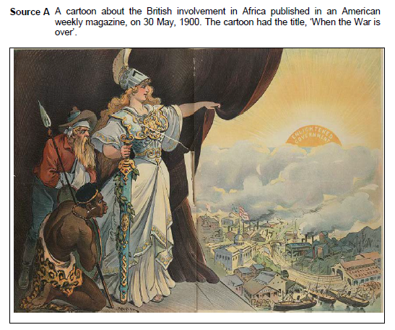
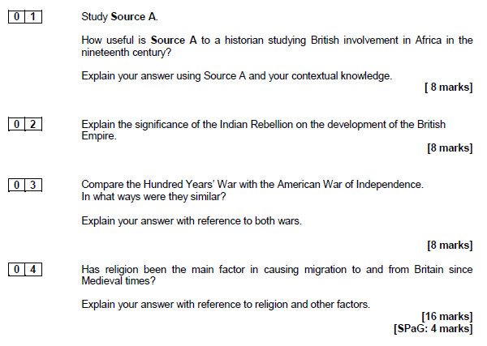

Paper 2: Unit 2
Elizabethan England, c. 1568 - 1603
Part One: Elizabeth’s Court and Parliament
Elizabeth I and her Court | Learning Checklist
Background and character of Elizabeth I
Patronage and progresses
Key ministers
The Privy Council
Relations with Parliament
Early issues: religion, Mary Queen of Scots, taxation, foreign policy
The problems of a female ruler | Learning Checklist
The problem of marriage and the succession
Elizabeth’s strength at the end of her reign, including Essex’s rebellion
Part 2: Life in Elizabethan Times
A ‘Golden Age’ | Learning Checklist
Living standards and fashions
Growing prosperity and the rise of the gentry
The Elizabethan Theatre: attitudes to it and its achievements
Architecture
The Poor | Learning Checklist
Reasons for the increase in poverty
Attitudes and responses to poverty
Reasons for government action
English Sailors | Learning Checklist
John Hawkins and the early slave trade
Walter Raleigh
Francis Drake’s circumnavigation
Part Three: Troubles at Home and Abroad
Religious matters | Learning Checklist
English Catholicism and Protestantism and the religious settlement
The Northern Rebellion
Elizabeth’s excommunication
Catholic plots
Puritanism and Elizabeth’s response
Mary, Queen of Scots | Learning Checklist
Mary, Queen of Scots’ background
Elizabeth and Parliament’s treatment of Mary
The challenge posed by Mary: plots and her execution
Conflict with Spain | Learning Checklist
Reasons for conflict, including Philip II, Dutch War, religion, privateers
Naval warfare, including tactics and technology
The defeat of the Spanish Armada
Part Four: Historic Environment
The Globe | Learning Checklist
People connected to the Globe
How the theatre was structured
How the theatre changed
What the theatre tells us about Elizabethan society
What the performances were like – content and messages

Keywords
Write a definition for the key words and add in any statistics or additional information that you can. Remember if you are using the internet to help you, you must be specific towards the course and time period.
Abdicate
Accession
Allegory
Alms
Ambassador
Anglican
Aristocracy
Armada
Broadside
Burgess
Calvinist
Censorship
Circumnavigation
Clergy
Colony
Conspiracy
Courtier
Cult
Culverin
Dearth
Death warrant
Empire
Excommunicated
Galleon
Gentry
Great Chain of Being
Heir
Heretic
House arrest
Huguenot
Humanism
Illegitimate
Jesuit
Justice of the Peace
Legislation
Martyr
Mass
Monasteries
Monopolies
Nationalism
New World
Papal Bull
Patronage
Peers
Plantation
Poor Laws
Poor rate
Printing press
Privateers
Privy Council
Progresses
Propaganda
Prophesying
Puritan
Pursuivants
Queen Regnant
Recoinage
Recusant
Reformation
Regent
Regicide
Renaissance
Sacrament
Seminary
Suitor
Traitor
Transubstantiation
Treason
Uniformity
Vagabond
Vagrant
Workhouse
Yeoman

Key People
Who were these people, and why were they important?
William Cecil
Francis Walsingham
Mary, Queen of Scots
James I
Robert Dudley
Philip II of Spain
Francis, Duke of Anjou and Alençon
The Duke of Norfolk
The Earl of Northumberland
The Earl of Westmorland
Robert Devereux, Earl of Essex
Bess of Hardwick
William Shakespeare
Robert Smythson
Sir Francis Drake
Sir John Hawkins
Sir Walter Raleigh
Sir Francis Throckmorton
Sir Anthony Babington
Roberto di Ridolfi
Edmund Campion
Edmund Grindal
John Whitgift
The Duke of Medina Sidonia

Practice questions

Use the paper summary grid to help you answer the questions.
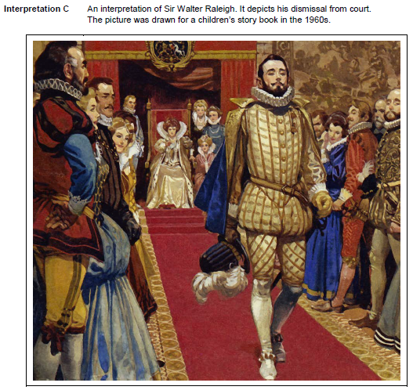

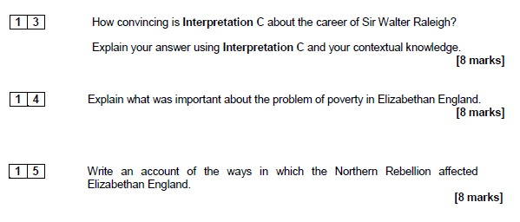
‘The main reason for building theatres was to demonstrate the new ideas and technology of the period’.

How far does a study of The Globe during the late Elizabethan period support this statement?

Explain your answer.

You should refer to The Globe and your contextual knowledge.

[16 marks]

